### 



### A

### DISSERTATION REPORT

**ON**

**Tumor Detection in Whole Slide Histopathology Images Using Machine**

**Learning with CNN Based Method**

SUBMITTED BY

### Miss. Sanika Nagnath Kendre

UNDER THE GUIDANCE OF

### Dr. V. V. Bag

DEPARTMENT OF COMPUTER SCIENCE AND ENGINEERING

### Master of Technology (Computer Science and Engineering)



**PRADNYA NIKETAN EDUCATION SOCIETY, PUNE.**

**NAGESH KARAJAGI ORCHID COLLEGE OF**

**ENGINEERING & TECHNOLOGY, SOLAPUR 413002**

AFFILIATED TO

### DR. BABASAHEB AMBEDKAR TECHNOLOGICAL UNIVERSITY, LONERE

### 2022 – 2023







### DECLARATION

I hereby declare that the Dissertation Report of the PG entitled **Tumor Detection in Whole Slide Histopathology Images Using Machine Learning with CNN Based Method** which is being submitted to the DR. Babasaheb Ambedkar Technological University, LONERE in Partial fulfillment of the requirements for the award of the M.Tech (Computer Science and Engineering) is a bonafide report of the work carried out by me. The material contained in this report has not been submitted to any University or Institution for the award of any degree.

### Miss. Sanika Nagnath Kendre

Place: NKOCET, Solapur

Date:

### 

### 

### DISSERTATION REPORT APPROVAL SHEET



The Dissertation Report entitled **Tumor Detection in Whole Slide Histopathology Images Using Machine Learning with CNN Based Method** submitted by **Miss. Sanika Nagnath Kendre** is hereby approved in partial fulfillment for the award of M.Tech. **DR. BABASAHEB AMBEDKAR TECHNOLOGICAL UNIVERSITY, LONERE.**

### EXAMINERS:

1.

### (External Examiner)

2. Dr. V. V. Bag

### (Internal Examiner)



DEPARTMENT OF COMPUTER SCIENCE AND ENGINEERING

### Master of Technology (Computer Science and Engineering)

### PRADNYA NIKETAN EDUCATION SOCIETY, PUNE.

### NAGESH KARAJAGI ORCHID COLLEGE OF ENGINEERING & TECHNOLOGY, SOLAPUR 413002

### 

### AFFILIATED TO

### DR. BABASAHEB AMBEDKAR TECHNOLOGICAL UNIVERSITY, LONERE

**2022 – 2023**

### 

### ACKNOWLEDGMENT



It’s my privilege to express my sincerest regards to my guide Dr. V. V. Bag for his valuable inputs, able guidance, encouragement, whole-hearted cooperation, and constructive criticism throughout the duration of our project. I would like to mention my sincere gratitude towards our Principal Dr. B.K.SONAGE and Head of the Department Dr. V. V. Bag for encouraging and allowing me to do this Dissertation Report at Department premises for the partial fulfillment of the requirements leading to the award of M-Tech degree.

I, take this opportunity to thank all my faculties who have directly or indirectly helped in my project. I pay my respects and love to my parents and all other family members and friends for their love and encouragement throughout my career. Last but not the least we express our thanks to our friends for their cooperation and support.

**Miss. Sanika Nagnath Kendre**

### 



### ABSTRACT

In the ever-advancing landscape of medical technology, the impending prominence of brain tumor related issues in medicine is evident. The accurate analysis of data becomes paramount in influencing predictions, monitoring, diagnosis, and treatment of brain tumor disorders. Given the life-threatening nature of brain tumor and their disruption of normal bodily functions, early detection becomes crucial for effective diagnosis and treatment planning. Digital image processing emerges as a key player in the analysis of medical images, particularly in understanding the intricacies of brain tumor development. The brain, being a highly specialized and sensitive organ, demands meticulous attention. Manual examination, prone to errors due to the complexities involved, necessitates the development of an automated system for early-stage brain tumor detection. Brain tumor, characterized by abnormal cell growth in the brain, poses significant challenges. Traditional detection methods, such as nuclear magnetic resonance (MRI), provide crucial insights into uncontrolled tissue growth. Notably, the application of CNN algorithms to MRI images accelerates brain tumor detection with enhanced accuracy; facilitating prompt decision-making by radiologists. The urgency in detecting brain tumor early arises from the rapid growth, with the average size doubling in just twenty-five days. Without proper treatment, the survival rate diminishes, emphasizing the need for fast and accurate detection. Automated systems for brain tumor detection prove essential, considering the swift progression and life-threatening nature of these abnormalities. This research focuses on finding brain tumor in the brain using advanced CNN computer techniques. The study is split into three main steps. In the first step, brain MRI images are pre-processed by applying some pre-processing techniques. In the second step, machine learning feature extraction methods are applied to pick out important features from these images. Finally, CNN models such as VGG, ResNet, DenseNet, and MobileNet are applied to classify the MRI images at a detailed level. The ensemble is done for majority voting to improve the accuracy of the classification of MRI images. This whole process aims to assist pathologists in understanding and identifying brain tumor more effectively. Automated defect detection in medical imaging has become a pivotal aspect of diagnostic applications. Detecting brain tumor automatically is crucial for obtaining information about abnormal tissues, aiding in future treatment planning. While the manual method involves human inspection, it proves time-consuming and error-prone, especially with large datasets. Hence, the development of automated brain tumor detection methods aims to save radiologists' time and improve the efficiency of early diagnosis.

### Table of Contents



**Table of Contents…………………………………………………………………………..i**

Certificate …………………………………………………………………………..ii

Acknowledgement …………………………………………………………………..v

Abstract ……………………………………………………………………………..vi

CHAPTER ONE

INTRODUCTION……………………………………………………………………...01

* 1. General Introduction………………………………………………………….01
  2. CNN…………………………………………………………………………..01
  3. Benefits of CNN……………………………………………………………...02
     1. No Require Human Supervision ……………………………………..02
     2. Automatic Feature Extraction………………………………………...02
     3. Highly Accurate at Image recognition and Classification…………....02
     4. Weight Sharing ……………………………………………………….02
     5. Minimizes Computation……………………………………………...02
     6. Ability to Handle Large Dataset…………………………………….. 03
     7. Hierarchical Learning………………………………………………...03
  4. Types of CNN………………………………………………………………..03
     1. VGG………………………………………………………………….03
     2. ResNet………………………………………………………………..03
     3. DenseNet……………………………………………………………..03
     4. MobileNet……………………………………………………………04
  5. Types of CNN services………………………………………………………04
     1. Image Classification Services………………………………………..04
     2. Object Detection Services……………………………………………04
     3. Medical Image Analysis Services……………………………………04
  6. Summary……………………………………………………………………..04

CHAPTER TWO

LITERATURE REVIEW…………………………………………………………….05

* 1. General Introduction………………………………………………………...05
  2. Detailed Survey of Literature………………………………………………..05
  3. Gap Identification…………………………………………………………...06
  4. Summary……………………………………………………………………..06

CHAPTER THREE

PROBLEM DEFINITION……………………………………………………………07

* 1. General Introduction………………………………………………………..07
  2. Aspects of CNN…………………………………………………………….07

First aspect relates to CNN Layers………………………………. .………….07

* + - 1. Convolutional Layer……………………………………………07
      2. Pooling Layer…………………………………………………..07
      3. Fully connected Layer………………………………………….07
    1. Second aspect relates to Activation Function……………………..07
    2. Third aspect relates to Data Augmentation……………………….08
  1. Existing System…………………………………………………………...08
  2. Disadvantages of existing system…………………………………………08
  3. Objective of the Work……………………………………………………..08
  4. Summary…………………………………………………………………..09

CHAPTER FOUR

PROPOSED METHODOLOGY…………………………………………………10

* 1. General Introduction……………………………………………………..10
  2. Methodology……………………………………………………………..10
  3. Summary…………………………………………………………………12

CHAPTER FIVE

SYSTEM DESIGN………………………………………………………………..13

5.1General Introduction…………………………………………………………13

5.2 Modules……………………………………………………………………...13

* + 1. Modules…………………………………………………………13
    2. VGG Module…………………………………………………….13
    3. ResNet Module………………………………………………….13
    4. DenseNet Module………………………………………………..14
    5. MobileNet Module……………………………………………....15
  1. Algorithms…………………………………………………………………...15
     1. CNN Classification for Brain Tumor……………………….15
     2. VGG19 CNN Classification for Brain Tumor……………...15
     3. ResNet CNN Classification for Brain Tumor……………....16
     4. DenseNet CNN Classification for Brain Tumor…………....16
     5. MobileNet CNN Classification for Brain Tumor…………..17
  2. UML Diagrams……………………………………………………………...17
     1. Data Flow Diagram………………………………………...17
     2. Use Case Diagram……………………………………….....18
     3. Class Diagram……………………………………………....19

5.4.4 Sequence Diagram…………………………………………..19

5.5.5 Activity Diagram……………………………………………20

5.5 Summary…………………………………………………………….........20



CHAPTER SIX



IMPLEMENTATION AND DEPLOYMENT………………………………21

6.1 General Introduction…………………………………………………..21

6.2 CNN Algorithms trained code………………………………………...21

6.3 Accuracy……………………………………………………………...25

6.4 Summary……………………………………………………………...28

CHAPTER SEVEN

TESTING AND PERFORMANCE…………………………………………..29

7.1 General Introduction………………………………………………….29

7.2 Results………………………………………………………………...29

* + 1. Select MRI Image Option…………………………………29
    2. Preprocessing the input MRI Image………………………30
    3. Detect the Brain tumor Type……………………………....31

7.3 Summary……………………………………………………………...33

CHAPTER EIGHT

CONCLUSION AND FUTURE SCOPE…………………………………….34

9.1 Conclusion…………………………………………………………34

* 1. Future Scope of the Work…………………………………………34

**REFERENCES………………………………………………………………………..35**

**PUBLISHED RESEARCH ARTICLE IN SCOPUS INDEXED JOURNAL OF INTEGRATED SCIENCE AND TECHNOLOGY………………………………………………........38**



**List of Figures**

Figure 1.1 CNN……………………………………………………………02

Figure 1.2 Types of CNN…………………………………………………..03

Figure 4.1 General System Architecture…………………………………..10

Figure 4.2 Detailed System Architecture………………………………….11

Figure 4.3 MRI Image Data Processing……………………………...........12

Figure 5.1 Data Flow Diagram……………………………………............18

Figure 5.2 Use Case Diagram…………………………………………….18

Figure 5.3 Class Diagram…………………………………………………19

Figure 5.4 Sequence Diagram…………………………………………….19

Figure 5.5 Activity Diagram………………………………………………20

Figure 6.3 Graph…………………………………………………………..27

Figure 6.5 Confusion Matrix………………………………………………27

### 



### **List of Screenshots**

Screenshot 7.1 Select MRI Image Option……………………………………….29

Screenshot 7.2 Preprocessing the Input MRI image…………………………….30

Screenshot 7.3 Normal Brain……………………………………………………30

Screenshot 7.4 Glioma Brain Tumor……………………………………………31

Screenshot 7.5 Meningioma Brain Tumor………………………………………32

Screenshot 7.6 Pituitary Brain Tumor…………………………………………...32

### 

### CHAPTER ONE

## INTRODUCTION

* 1. **General Introduction**

In this section, basics of Convolutional Neural Network (CNN), benefits of CNN like No require human supervision, Automatic feature extraction, Weight sharing etc. are discussed. It also describes different types of CNN and the different CNN services.

### 1.2 Convolutional Neural Network (CNN)

A convolutional neural network (CNN or convent) is a subset of [machine learning](https://www.techtarget.com/searchenterpriseai/definition/machine-learning-ML). It is one of the various types of artificial [neural networks](https://www.techtarget.com/searchenterpriseai/definition/neural-network) which are used for different applications and data types. A CNN is a kind of network architecture for [deep learning](https://www.techtarget.com/searchenterpriseai/definition/deep-learning-deep-neural-network) algorithms and is specifically used for [image recognition](https://www.techtarget.com/searchenterpriseai/definition/image-recognition) and tasks that involve the processing of pixel data.

There are other types of neural networks in deep learning, but for identifying and recognizing objects, CNNs are the network architecture of choice. This makes them highly suitable for computer vision tasks and for applications where object recognition is vital. The CNN is another type of neural network that can uncover key information in both time series and image data. For this reason, it is highly valuable for image-related tasks, such as image recognition, object classification and pattern recognition. To identify patterns within an image, a CNN leverages principles from linear algebra, such as matrix multiplication. CNNs can also classify audio and signal data. CNNs also have neurons arranged in a specific way. In fact, a CNN's neurons are arranged like the brain's frontal lobe, the area responsible for processing visual stimuli. This arrangement ensures that the entire visual field is covered, thus avoiding the piecemeal image processing problem of traditional neural networks, which must be fed images in reduced-resolution pieces. Compared to the older networks, a CNN delivers better performance with image inputs. “Convolutional Neural Networks or CNNs, are a special kind of neural network for processing data that has a known, grid-like topology. Examples include time-series data, which can be thought of as a 1D grid taking samples at regular time intervals, and image data, which can be thought of as a 2D grid of pixels. Convolutional networks have been tremendously successful in practical applications.

The name “convolutional neural network” indicates that the network employs a mathematical operation called convolution. Convolution is a specialized kind of linear operation. CNNs are very similar to ordinary Neural Networks — they are made up of neurons that have learnable weights and biases. Each neuron receives some inputs, performs a dot product and optionally follows it with a non-linearity. It will be easy to visualize. A convolutional neural network is a feed-forward neural network that is generally used to analyze visual images by processing data with grid-like topology.

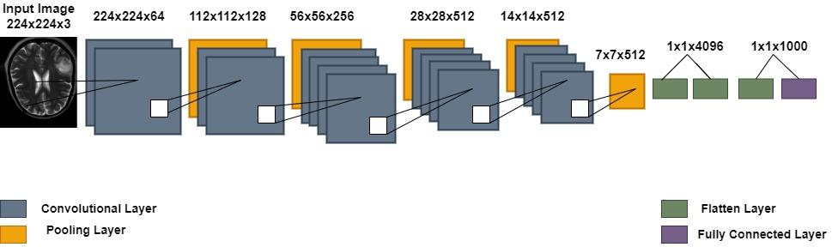

**Figure 1.1: CNN Layer Processing**

### Benefits of CNN

### No require human supervision

CNN is that they do not require human supervision for image classification and identifying important features in images.

### Automatic feature extraction

Automatic feature extraction is firstly evaluated on a number of benchmark datasets and then a simple traditional Multi-Layer Perceptron (MLP) with full image, and manual feature extraction are evaluated on the same benchmark datasets.

### Highly accurate at image recognition & classification

These convolutional neural network models are ubiquitous in the image data space. They work phenomenally well on computer vision tasks like image classification, object detection, image recognition, etc. They have hence been widely used in artificial intelligence modeling, especially to create image classifiers.

* + 1. **Weight sharing**

In CNNs, each filter has a set of weights (parameters) associated with it, and these weights are shared across all the neurons that use that filter. This is also known as parameter sharing.

### Minimizes computation

We generally use a pooling layer to shrink the height and width of the image. To reduce the number of channels from an image, we convolve it using a 1 X 1 filter (hence reducing the computation cost as well).

### Ability to handle large datasets

It handles large datasets using above steps Get the data. Prepare the data, define the model, Train the model, Explore the results and Test your model.

### Hierarchical learning

A hierarchical CNN classifier consists of multiple CNN models at different levels. How can we leverage the commonalities among these models and effectively train them all? Third, it would also be slower and more memory consuming to run a hierarchical CNN classifier on a novel testing image.

### Types of CNN

The capacity of CNN to utilize spatial or temporal correlation in data is one of its most appealing features. CNN is separated into numerous learning stages, each of which consists of a mix of convolutional layers, nonlinear processing units, and subsampling layers. CNN is a feed forward multilayered hierarchical network in which each layer conducts several transformations using a bank of convolutional kernels. The convolution procedure aids in the extraction of valuable characteristics from data points that are spatially connected.

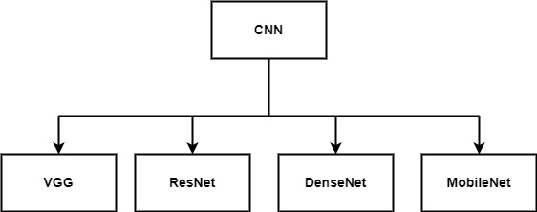

**Figure 1.2: Types of CNN**

### VGG

VGG19 is a convolutional neural network (CNN) architecture that belongs to the VGG (Visual Geometry Group) family of models. It was introduced by the Visual Geometry Group at the University of Oxford and is known for its simplicity and effectiveness. VGG19 specifically refers to a model with 19 layers, including convolutional and fully connected layers.

### ResNet

ResNet, short for Residual Network, is a deep convolutional neural network architecture designed to address the challenges of training very deep neural networks. It was introduced by Kaiming He, Xiangyu Zhang, Shaoqing Ren, and Jian Sun in their 2016 paper "Deep Residual Learning for Image Recognition."

### DenseNet

DenseNet, short for Densely Connected Convolutional Network, is a deep neural network architecture introduced by Gao Huang, Zhuang Liu, and Laurens van der Maaten in their 2017 paper titled "Densely Connected Convolutional Networks." DenseNet is known for its unique connectivity pattern and the dense connections between layers. It aims to alleviate the vanishing gradient problem and promote feature reuse throughout the network.

### MobileNet

MobileNet is a family of lightweight deep neural network architectures designed for mobile and edge devices with resource constraints. The original MobileNet architecture, known as MobileNetV1, was introduced by Andrew G. Howard, Menglong Zhu, Bo Chen, Dmitry Kalenichenko, Weijun Wang, Tobias Weyand, Marco Andreetto, and Hartwig Adam in their 2017 paper titled "MobileNets: Efficient Convolutional Neural Networks for Mobile Vision Applications.

### 1.5 Types of CNN services

Convolutional Neural Networks (CNNs) have found extensive applications in various domains, and several types of services and applications leverage CNNs for different purposes. Here are some common types of CNN services:

**1.5.1 Image Classification Services:**

Image classification services use CNNs to categorize images into predefined classes or labels. These services are used in various applications, such as content moderation, object recognition, and automated tagging.

### ****Object Detection Services:****

Object detection services leverage CNNs to identify and locate objects within images or video frames. These services are employed in applications like autonomous vehicles, surveillance systems, and augmented reality.

* + 1. **Medical Image Analysis Services:**

CNNs are extensively used in medical image analysis services for tasks such as tumor detection, pathology recognition, and organ segmentation. These services contribute to advancements in healthcare and diagnostics.

### Summary

In this chapter, basics of CNN, benefits of CNN are discussed. It also described different types of CNN and the CNN services.

## CHAPTER TWO

## LITERATURE REVIEW

### 2.1 General Introduction

In this section, various research papers are discussed. Based on research papers, identified few gaps in existing systems. Mentioned below the detailed survey of literature.

### Detailed Survey of Literature

In the research paper [4] by Ramdas Vankdothu, et.al. explained these scans are commonly employed in diagnosing various conditions like head traumas, malignancies, and skull injury. Primary focus was on enhancing the efficiency and simplifying the complexity associated with the segmentation process of CT-based images. By investigating and refining the segmentation techniques specific to CT scans, aim to contribute to a more streamlined and effective approach to identifying and delineating brain tumors in these diagnostic images. This research holds promise for improving the overall diagnostic process for conditions affecting the brain, offering potential benefits in terms of accuracy and speed.

In the research paper [5] by Yi-Xin Huang, et.al. CNN-based deep learning model is suggested for sorting many forms of brain tumors, where the design has an ordering accuracy for the group of brain tumor types. In the research paper [6] by Hossain, Roliana by showing a bibliometric review, the researchers aim to contribute to the collective understanding of automated brain tumor detection, offering valuable insights to researchers, practitioners, and stakeholders in the medical and machine learning communities. This type of study is crucial for staying abreast of the latest developments in the field, guiding future research directions, and ultimately advancing the capabilities of automated brain tumor detection systems.

In the research paper [7] by Ashwini S Shinde, et.al. explore and evaluate several cutting-edge Machine Learning techniques designed for tumor classification, distinguishing between benign and malignant cases. The investigated methods encompass a diverse array of approaches, including Logistic Regression, Multilayer Perceptron, Decision Trees, Naive Bayes classifier, and Support Vector Machines. The aim is to comprehensively analyze the effectiveness and performance of each technique in the critical task of tumor classification. By delving into these state-of-the-art methodologies, seek to discern their respective strengths and limitations, providing valuable insights into their applicability and potential contributions to enhancing the accuracy and reliability of tumor diagnosis. In the research paper [8] by Omer Turk, et.al. to develop an automated system for detecting brain tumors using advanced deep learning models, namely ResNet50, InceptionV3, and Mobile Net focusing on analyzing brain images, a crucial diagnostic tool. Additionally, we're incorporating Class Activation Maps (CAMs) indicators to enhance the interpretability of the models.

By doing this, aim to create a more accurate and reliable method for identifying brain tumors through the combination of these powerful deep learning architectures and meaningful visualizations provided by CAMs. This approach could potentially improve the efficiency and precision of brain tumor diagnosis using MRI scans. The research paper [9] by Parvin Razzaghi, et.al. described addressing the challenge of brain image segmentation, the concept of knowledge transfer, both between and within different modalities. A key aspect of this transfer is domain adaptation, which plays a crucial role in overcoming the issue of disparate distributions between the sets used for training and testing. In the research paper [10] by Arkapravo Chattopadhyay, et.al. explained the goal is to improve the accuracy of detecting and categorizing brain tumors in MRI images by combining the strengths of both advanced neural networks and established classification techniques. This approach could lead to more precise and reliable results in identifying and understanding brain abnormalities from medical images. In the research paper [11] by K.S. Ananda Kumar, et al informed in simple terms, using a sophisticated neural network that has been pre-trained on a large dataset (inspired by nature) to quickly and accurately identifies and categorizes brain images. This approach combines the strengths of deep learning and transfer learning, aiming to improve the efficiency and accuracy of detecting various features in brain images for better classification.

### Gap Identification

Based on above research, it is found that there are certain gaps in existing system which can be corrected in this project. Below are the identified gaps in existing system: In the early layers of a CNN designed for brain tumor detection, convolutional layers are employed to extract hierarchical features from the input images. These features capture different levels of information, ranging from simple edges to more complex textures and patterns associated with brain tumor.

### Summary

In this chapter, we discussed about various research papers which provided different ways of detecting brain tumor. Based on those we also found gap in existing system.

## CHAPTER THREE

## PROBLEM DEFINITION

## General Introduction

The problem statement based on the identified gap for brain tumor detection in MRI images using different types of CNN can be formulated as follows: Developing an accurate and interpretable CNN-based model for brain tumor in MRI images, considering the challenges of limited availability of large-scale annotated datasets. It ensembles brain tumor using frequent CNN algorithms.

* 1. **Aspects of CNN**

Above problem will be explained in aspects: CNN layers, activation function and data augmentation are discussed below:

* + 1. **First aspect relates to CNN layers:**

It provides information related to different types of CNN layers.

**3.2.1.1 Convolutional Layers:**

Convolutional layers are the core building blocks of CNNs. They use convolutional operations to scan input data with small filters, capturing local patterns and features. Filters are weights that are learned during the training process.

**3.2.1.2 Pooling Layers:**

Pooling layers, such as max pooling or average pooling, are used to down sample the spatial dimensions of the feature maps generated by convolutional layers. Pooling helps reduce computational complexity and retains the most important information.

* + - 1. **Fully Connected Layers:**

Fully connected layers are often used at the end of the network for classification tasks. Neurons in these layers are connected to all neurons in the previous layer, helping the network make predictions based on the learned features.

* + 1. **Second aspect relates to activation function:**

In Convolutional Neural Networks (CNNs), activation functions play a crucial role in introducing non-linearity to the model. They are applied to the output of each convolutional layer, helping the network learn complex patterns and relationships in the data.

* + - 1. **Activation Function**

Activation functions, typically Rectified Linear Unit (ReLU) activations, introduce non- linearity to the network. ReLU helps the network learn complex relationships in the data by allowing it to model non-linear patterns.

* + 1. **Third aspect relates to Data Augmentation:**

Data augmentation is a technique commonly used in Convolutional Neural Networks (CNNs) to artificially increase the size of the training dataset by applying various transformations to the existing images. This helps improve the generalization and robustness of the model, reducing the risk of overfitting.

* + - 1. **Data Augmentation**

Data augmentation involves applying random transformations to the input data during training, such as rotations, flips, and zooms. This helps improve the model's robustness and generalization by exposing it to diverse variations of the input data.

* 1. **Existing System**
* Existing system for detecting brain tumor using different types of CNN algorithms like VGG, ResNet, DenseNet and Mobilenet
* System recognizes which type of brain tumor occurs
* In existing system, types of brain tumor are Normal Brain, Glioma brain tumor, Meningioma brain tumor and Pituitary brain tumor.

**3.4 Disadvantages of existing system**

**False Positives and False Negatives:** CNNs may produce false positives (incorrectly identifying a tumor when none is present) or false negatives (missing a tumor that is present). These errors can have serious consequences in a medical context and need to be minimized for clinical applicability.

**Overfitting:** CNNs, especially when trained on limited data, are susceptible to overfitting. Overfitting occurs when the model memorizes the training data rather than learning generalizable features. This can result in poor performance on new, unseen data.

**3.5 Objective of the Work**

Detecting brain tumor poses challenges due to the diverse nature of tumor tissues among different patients, often resembling normal tissues, making the task complex.

The primary objective is to accurately classify the presence of a brain tumor or a healthy brain, enabling early-stage detection.

This methodology enhances the speed and precision of brain tumor detection, providing automation in image processing and analysis, thereby improving the identification of brain structures in the realm of medical science. The focus extends to brain tumor Segmentation, a critical medical image analysis task involving the separation of brain tumor from normal brain tissue in imaging scans.

Leveraging convolutional neural networks (CNN) proves advantageous, as they autonomously learn intricate features from multi-modal brain images, enhancing accuracy. This approach not only automates image processing but also contributes to the refined identification of both healthy and brain tumor tissues.

Recognizing the pivotal role of early-stage brain tumor detection in increasing patient recovery chances after treatment, the study emphasizes the importance of image processing.

The fundamental objective is to convert images into a digital format, enabling specific operations for obtaining models or extracting pertinent information from the images. The main goal is to significantly reduce the fatality rate associated with brain tumor, underscoring the importance of early identification.

The study aims to streamline the detection and classification of brain tumor, particularly through the development of a segmentation and detection method utilizing MRI sequence images. This method serves as a valuable tool for identifying brain tumor areas, contributing to the broader effort to improve outcomes in brain tumor diagnosis and treatment.

**3.6 Summary**

In this chapter, we discussed about few aspects of security like CNN Layers, activation function and data augmentation. We also went through the disadvantages of existing system and finally the objective of this project.

## CHAPTER FOUR

## PROPOSED METHODOLOGY

## General Introduction

This section of project contains the information about proposed methodology of this project which mentions about the different types of CNN algorithms.

* 1. **Methodology**

According to the literature review, automated detection of brain tumor is imperative, particularly when human lives are at stake, demanding high accuracy. The automated process involves the extraction of features and classification CNN algorithms. This paper introduces a system designed for the automatic detection of brain tumor in MRI images. The application of various imaging techniques serves the ultimate purpose of extracting crucial information from the given MRI images. While the classification of brain tumor is a vital yet time-intensive task performed by medical experts, the digital image processing community has made significant strides, developing numerous machine learning algorithms and CNN models. Extensive research has explored brain tumor detection using image processing and soft computing techniques, each with its distinct advantages. The paper delves into the methods and algorithms employed in the proposed approach for the classification of brain MRI images. In Fig.4.1 it is shown the how data is pre-processed for training the various CNN models to make a trained classification model for brain tumor detection. It shows rough idea about structure of the MRI brain tumor detection and classification.

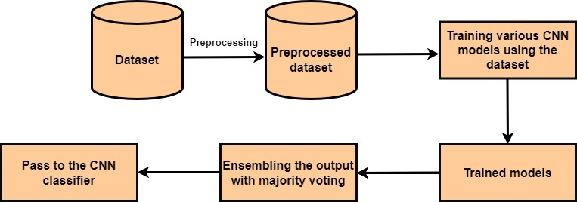

**Figure4.1. General System Architecture**

In Fig.4.2 detailed system architecture of brain tumor detection and classification is shown. In first step MRI image to, train the classification algorithm using the MRI brain dataset. The accuracy of the learned model is calculated and it is evaluated. The various CNN models such as VGG, ResNet, DenseNet and MobileNet to make the best classification model for the detection of brain tumor and gives brain images of patients as input to the classification model at the last ensemble the classification output for majority voting to detect the brain tumor.

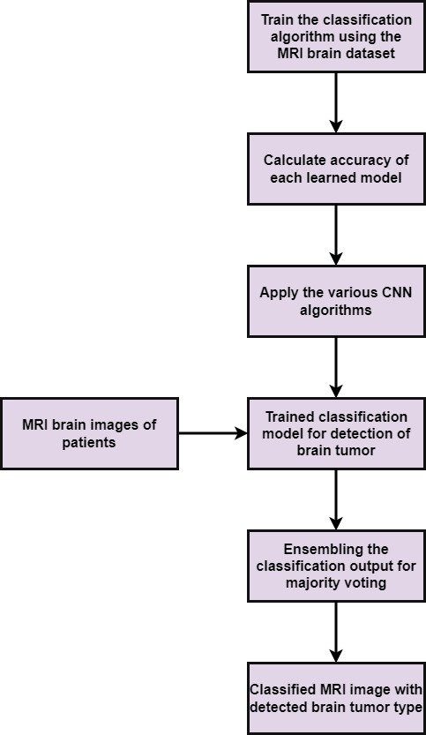

**Figure4.2. Detailed System Architecture**

The dataset includes 1320 images of human brain MRI. These images are classified into three types: glioma, meningioma, and pituitary. 330 images of glioma brain tumor, raises to cancer that disturbs the brain, cranial nerves, or other portions of the nervous system. 330 images of pituitary abnormal brain growth, Pituitary brain tumor.

Initiate in the pituitary gland, which is found inside the skull but is not part of the brain.330 images of meningioma brain tumors, On the other hand, meningioma tumors develop from the meninges, the membrane that shields the brain and spinal cord. They are the most common primary brain tumors in adults. And the other 330 are normal brains.

To enhance accuracy, preprocessing steps are undertaken to eliminate artifacts present in these images. In Fig4.3 the processing time is optimized by excluding unnecessary information from the image background, such as the skull, background and scalp, leaving only the region of interest. The Brain Surface Extractor employed to effectively remove the brain and skull. Preprocessing proves essential as it not only eliminates unwanted elements but also improves the overall image data, enhancing crucial features necessary for subsequent processing steps.

A VGG19 (Visual Geometry Group 19) Convolutional Neural Network (CNN) architecture is a type of deep neural network it consists of 19 layers that employs various convolutional layers to sift through inputs and extract useful information. Convolutional filters are applied to the input data in these layers, calculating the output of neurons linked to specific regions in the input. Fig.4 the CNN model consists of four key layers: a convolutional layer, a pooling layer, flatten layer and a fully connected layer. The convolutional layer involves essential parameters like stride, padding, and filter size. Multiple filters are utilized in each layer to extractdetailed features. The filters move across the images based on a specified stride, where a stride size of one or two is typically employed; exceeding this value can negatively impact CNN performance. Each convolutional layer is designed to carry out a specific task in the overall process. The number of filters increases deeper into the network, providing a hierarchical feature representation. Pooling layer helps reduce the spatial dimensions of the feature maps, leading to a more compact representation and capturing the most important features, it preserves important information extracted by the convolutional layers. Flatten layer connecting the spatial information captured by to the densely connected layers that make classification decisions. Fully connected layer uses softmax activation to produce probability scores for different classes. These scores in the presence of each class in the input image. After completing all layers it classifies whether the brain tumor has occur or not.



**Figure4.3. MRI Image Data Processing**

**4.3 Summary**

Here, we discussed about how CNN works for detecting brain tumor and overview of CNN models.

## CHAPTER FIVE

## SYSTEM DESIGN

### General Introduction

### In this section details of system design including number of modules and its description, different algorithms and UML diagrams are discussed.

### Modules

### This project consists of four modules named as “VGG”, “ResNet”, “DenseNet” and “MobileNet”, which are described as below:

### 5.2.1 VGG CNN Module

### The VGG (Visual Geometry Group) CNN model, and specifically VGG16 and VGG19, are deep convolutional neural network architectures designed for image classification. VGG was introduced by the Visual Geometry Group at the University of Oxford, and it gained popularity for its simplicity and effectiveness. Here, I'll provide a brief description of the VGG19 model

### VGG19 is an extension of VGG16 and includes four additional convolutional layers. The primary difference lies in the increased depth of the model. The architecture is similar, with additional convolutional layers and corresponding adjustments in the number of parameters.

### ****Homogeneous Structure:**** VGG models have a homogeneous structure with a consistent 3x3 convolutional filter size and max-pooling layers

### ****Parameter Efficiency:**** Despite their deep architecture, VGG models are known for their parameter efficiency, meaning they can achieve good performance with fewer parameters compared to some other architecture.

### ****Ease of Transfer Learning:**** The homogeneous structure makes VGG models well-suited for transfer learning. Pre-trained models on large datasets (e.g., ImageNet) can be fine-tuned for specific tasks with limited data.

### ****Computational Intensity:**** VGG models can be computationally intensive due to their depth and the large number of parameters, making training and deployment on resource-constrained devices challenging.

### 5.2.2 ResNet CNN Module

### ResNet, short for Residual Network, is a deep convolutional neural network architecture designed to address the challenges of training very deep neural networks. ResNet was introduced by Kaiming He, Xiangyu Zhang, Shaoqing Ren, and Jian Sun in their 2016 paper "Deep Residual Learning for Image Recognition." The key innovation of ResNet is the use of residual blocks, which enable the training of very deep networks without suffering from vanishing or exploding gradient problems.

### ****Residual Learning:**** ResNet introduces the concept of residual learning, where the model learns the residual mapping (the difference between input and output) instead of the direct mapping. This eases the training of very deep networks.

### ****Shortcut Connections:**** The use of shortcut connections helps address the vanishing gradient problem and accelerates the training process. It allows the gradient to be directly propagated to earlier layers.

### ****Parameter Efficiency:**** Despite its depth, ResNet is parameter-efficient, and the use of bottleneck blocks further reduces the computational cost.

### ****Transfer Learning:**** Pre-trained ResNet models on large datasets, such as ImageNet, can be effectively fine-tuned for specific tasks with limited data.

### ResNet has become a widely used and influential architecture in the field of computer vision, and its principles have been incorporated into much subsequent architecture. The ability to train very deep networks has contributed to significant advancements in image recognition, object detection, and other visual perception tasks.

### 5.2.3 DenseNet CNN Module

### DenseNet, short for Densely Connected Convolutional Network, is a deep convolutional neural network architecture designed to encourage feature reuse and alleviate some of the issues associated with vanishing gradients in very deep networks. DenseNet was introduced by Gao Huang, Zhuang Liu, and Laurens van der Maaten in their 2017 paper "Densely Connected Convolutional Networks."

### ****Feature Reuse:**** Dense connectivity promotes feature reuse, allowing each layer to access the gradients from the loss function directly. This can improve the flow of information and gradients throughout the network.

### ****Parameter Efficiency:**** Despite its depth, DenseNet is parameter-efficient compared to traditional architectures. The dense connections allow the model to capture diverse features using fewer parameters.

### ****Reduction in Vanishing Gradient Problem:**** Dense connectivity mitigates the vanishing gradient problem by providing shorter paths for the gradient to flow through the network during back propagation.

### ****Improved Accuracy:**** DenseNet architectures have been shown to achieve competitive or superior accuracy on various image classification tasks compared to other architectures.

### ****Adaptability to Different Image Sizes:**** DenseNet's architecture allows for efficient adaptation to different input image sizes, making it suitable for a variety of tasks.

### DenseNet has been widely adopted in computer vision tasks, including image classification, object detection, and segmentation. Its unique connectivity pattern and efficient use of parameters make it a powerful architecture for leveraging the benefits of deep learning.

### MobileNet CNN Module

### MobileNet refers to a family of convolutional neural network architectures designed for efficient mobile and embedded vision applications. These networks were developed by Google researchers to address the challenges of deploying deep learning models on resource-constrained devices, such as mobile phones and other edge devices. MobileNet architectures focus on achieving a good balance between model size, accuracy, and computational efficiency.

### 5.3 Algorithms

### Below are the algorithms used in this project.

### CNN Model

**Algorithm: CNN Classification for Brain Tumor Type**

**Input: Brain Image**

**Output: Classified Brain Tumor Type**

* Use the MRI image dataset for model training
* Train the model using convolutional neural network (VGG, ResNet, DenseNet, and MobileNet)
* Using cross validation score calculate the accuracy of various models
* Input the test image 100X100 pixels.
* Use trained model to predict the class label of brain tumor
* Make a list of predicted class labels for various trained models
* By ensembling find the final class label of the tumor by majority voting

### VGG CNN Model

**Algorithm: Utilizing the VGG19 CNN model for classifying brain tumor type**

**Input: Brain Image**

**Output: Classified Brain Tumor Type**

* Use the MRI image dataset for model training
* Train the model using convolutional layer with 64 filters, 128filters, 256 filters and 512 filters each with a 3x3 kernel, and employs the ReLU activation function.
* Using flatten layer, producing a flattened output in the form of a 1D vector.
* Using fully connected layer, with softmax function it ensures that the final prediction.
* Input the test image 100X100 pixels.
* Use trained model to predict the class label of brain tumor
* Make a list of predicted class labels for various trained models
* By ensembling find the final class label of the tumor by majority voting

### **ResNet CNN Model**

**Algorithm: Using ResNet CNN Model Classification for Brain Tumor Type**

**Input: Brain Image**

**Output: Classified Brain Tumor Type**

* Use the MRI image dataset for model training
* Train the model using convolutional layer with 64 filters, 128filters, 256 filters and 512 filters each with a 7x7 kernel, and employs the ReLU activation function.
* Model use Multiple residual blocks for convolutional layers
* Applying batch normalization to obtain higher classification accuracy
* pooling is applied to reduce the spatial dimensions of model
* Using fully connected layer, with softmax function it ensures that the final prediction.
* Input the test image 100X100 pixels.
* Use trained model to predict the class label of brain tumor
* Make a list of predicted class labels for various trained models
* By ensembling find the final class label of the tumor by majority voting

### MobileNet CNN Model

**Algorithm: Using MobileNet CNN Model Classification for Brain Tumor Type**

**Input: Brain Image**

**Output: Classified Brain Tumor Type**

* Use the MRI image dataset for model training
* Train the model using convolutional layer with 64 filters, 128filters, 256 filters and 512 filters each with a 3x3 kernel, and employs the ReLU activation function and batch normalization.
* In model series of depth-wise convolutional blocks are stacked.
* pooling is applied to reduce the spatial dimensions of model
* Repeat the depth-wise convolutional blocks multiple times. The number of repetitions can be adjusted based on the desired model complexity.
* Using fully connected layer, with softmax function it ensures that the final prediction.
* Input the test image 100X100 pixels.
* Use trained model to predict the class label of brain tumor
* Make a list of predicted class labels for various trained models
* By ensembling find the final class label of the tumor by majority voting

### DenseNet CNN Model

**Algorithm: Using DenseNet CNN Model Classification for Brain Tumor Type**

**Input: Brain Image**

**Output: Classified Brain Tumor Type**

* Use the MRI image dataset for model training
* Train the model using convolutional layer with 64 filters, 128filters, 256 filters and 512 filters each with a 7x7 kernel, and employs the ReLU activation function and batch normalization.
* Model uses a series of dense blocks. Each dense block consists of multiple dense layers.
* Model use transition block to reduce the spatial dimensions..
* pooling is applied to reduce the spatial dimensions of model
* Model Connect a dense layer to the output of pooling layer.
* Input the test image 100X100 pixels.
* Use trained model to predict the class label of brain tumor
* Make a list of predicted class labels for various trained models
* By ensembling find the final class label of the tumor by majority voting

### 

### UML Diagrams

### A UML diagram is a diagram based on the UML (Unified Modeling Language) with the purpose of visually representing a system along with its main actors, roles, actions, artifacts or classes, in order to better understand, alter, maintain, or document information about the system. UML is a way to visually represent the architecture, design, and implementation of complex software systems. When you’re writing code, there are thousands of lines in an application, and it’s difficult to keep track of the relationships and hierarchies within a software system. UML diagrams divide that software system into components and subcomponents.

### Data Flow Diagram

### The DFD is also called as bubble chart. It is a simple graphical formalism that can be used to represent a system in terms of input data to the system, various processing carried out on this data, and the output data is generated by this system.

### The data flow diagram (DFD) is one of the most important modeling tools. It is used to model the system components. These components are the system process, the data used by the process, an external entity that interacts with the system and the information flows in the system

### DFD shows how the information moves through the system and how it is modified by a series of transformations. It is a graphical technique that depicts information flow and the transformations that are applied as data moves from input to output.

### DFD is also known as bubble chart. A DFD may be used to represent a system at any level of abstraction. DFD may be partitioned into levels that represent increasing information flow and functional detail.

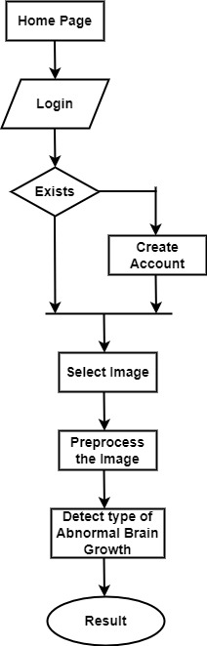

**Figure 5.1: Data Flow Diagram**

### Use Case Diagram

### A use case diagram in the Unified Modeling Language (UML) is a type of behavioral diagram defined by and created from a Use-case analysis. Its purpose is to present a graphical overview of the functionality provided by a system in terms of actors, their goals (represented as use cases), and any dependencies between those use cases. The main purpose of a use case diagram is to show what system functions are performed for which actor. Roles of the actors in the system can be depicted.

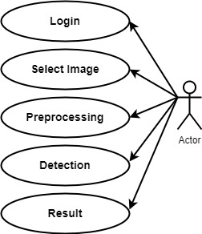

**Figure 5.2: Use Case Diagram**

### Class Diagram

### In software engineering, a class diagram in the Unified Modeling Language (UML) is a type of static structure diagram that describes the structure of a system by showing the system's classes, their attributes, operations (or methods), and the relationships among the classes. It explains which class contains information.

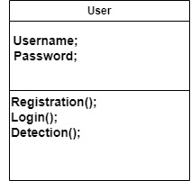

**Figure 5.3: Class Diagram**

### Sequence Diagram

### A sequence diagram in Unified Modeling Language (UML) is a kind of interaction diagram that shows how processes operate with one another and in what order. It is a construct of a Message Sequence Chart. Sequence diagrams are sometimes called event diagrams, event scenarios, and timing diagrams.

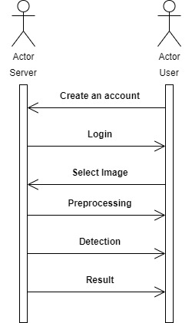

**Figure 5.4: Sequence Diagram**

### Activity Diagram

Activity diagrams are graphical representations of workflows of stepwise activities and actions with support for choice, iteration and concurrency. In the Unified Modeling Language, activity diagrams can be used to describe the business and operational step-by-step workflows of components in a system. An activity diagram shows the overall flow of control.

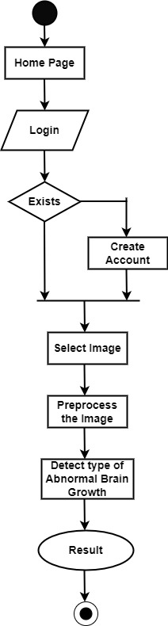

**Figure 5.5: Activity Diagram**

**5.5 Summary**

In above sections, we discussed about different algorithms used in this project. Module wise analysis of system design is also discussed along with UML diagrams.

## CHAPTER SIX

## IMPLEMENTATION AND DEPLOYMENT

### General Introduction

In this section, the summary of technologies used in developing this project is discussed.

* 1. **CNN Algorithms Trained Code**

It contains trained algorithm code.

*# Build, train, and evaluate VGG model*

*vgg_model = build_vgg_model()*

*vgg_model.compile(*

*optimizer=optimizers.SGD(lr=0.01),*

*loss='categorical_crossentropy',*

*metrics=['accuracy']*

*)*

*vgg_datagen = ImageDataGenerator(*

*rescale=1./255,*

*shear_range=0.2,*

*zoom_range=0.2,*

*horizontal_flip=True*

*)*

*vgg_training_set = vgg_datagen.flow_from_directory(*

*basepath + '/training_set',*

*target_size=(100, 100),*

*batch_size=32,*

*class_mode='categorical'*

*)*

*vgg_test_set = vgg_datagen.flow_from_directory(*

*basepath + '/test_set',*

*target_size=(100, 100),*

*batch_size=32,*

*class_mode='categorical'*

*)*

*vgg_steps_per_epoch = int(np.ceil(vgg_training_set.samples / 32))*

*vgg_val_steps = int(np.ceil(vgg_test_set.samples / 32))*

*vgg_history = vgg_model.fit_generator(*

*vgg_training_set,*

*steps_per_epoch=vgg_steps_per_epoch,*

*epochs=3,*

*validation_data=vgg_test_set,*

*validation_steps=vgg_val_steps*

*)*

*models.append(vgg_model)*

*histories.append(vgg_history)*

*vgg_scores = vgg_model.evaluate(vgg_test_set, verbose=1)*

*messages.append("VGG Testing Accuracy: %.2f%%" % (vgg_scores[1] * 100))*

The VGG model with the Stochastic Gradient Descent (SGD) optimizer, categorical cross entropy loss (suitable for multiclass classification problems), and accuracy as the evaluation metric. An ImageDataGenerator is created with various data augmentation parameters like rescaling, shearing, zooming, and horizontal flipping. Data augmentation helps improve the model's generalization by introducing variations in the training data. The flow_from_directory to generate batches of augmented data from the training and test sets. It assumes a directory structure where each class has its own subdirectory. The model is trained using the fit_generator method. It specifies the training generator, steps per epoch, number of epochs, validation data, and validation steps. The trained model and its training history are appended to lists for further analysis or comparison. The model is evaluated on the test set, and the testing accuracy is printed as part of a message.

*def build_resnet_model():*

*b ase_model = ResNet50(weights='imagenet', include_top=False,input_shape=(100, 100, 3))*

*model = Sequential()*

*model.add(base_model)*

*model.add(Flatten())*

*model.add(Dense(256, activation='relu'))*

*model.add(Dropout(0.5))*

*model.add(Dense(4, activation='softmax'))*

*return model*

*# Build, train, and evaluate ResNet model*

*resnet_model = build_resnet_model()*

*resnet_model.compile(*

*optimizer=optimizers.SGD(lr=0.01),*

*loss='categorical_crossentropy',*

*metrics=['accuracy']*

*)*

*resnet_datagen = ImageDataGenerator(rescale=1./255)*

*resnet_training_set = resnet_datagen.flow_from_directory(*

*basepath + '/training_set',*

*target_size=(100, 100),*

*batch_size=32,*

*class_mode='categorical'*

*)*

*resnet_test_set = resnet_datagen.flow_from_directory(*

*basepath + '/test_set',*

*target_size=(100, 100),*

*batch_size=32,*

*class_mode='categorical'*

*)*

*resnet_steps_per_epoch = int(np.ceil(resnet_training_set.samples / 32))*

*resnet_val_steps = int(np.ceil(resnet_test_set.samples / 32))*

*resnet_history = resnet_model.fit_generator(*

*resnet_training_set,*

*steps_per_epoch=resnet_steps_per_epoch,*

*epochs=3,*

*validation_data=resnet_test_set,*

*validation_steps=resnet_val_steps*

*)*

*models.append(resnet_model)*

*histories.append(resnet_history)*

*resnet_scores = resnet_model.evaluate(resnet_test_set, verbose=1)*

*messages.append("ResNet Testing Accuracy: %.2f%%" % (resnet_scores[1] * 100))*

This function build_resnet_model() creates a ResNet model using the pre-trained ResNet50 model available in Keras (weights='imagenet'). The top layer (fully connected layer) is excluded (include_top=False), and the input shape is specified as (100, 100, 3). Additional layers are added on top of the ResNet50 base, including flattening, a dense layer with 256 units and ReLU activation, dropout with a rate of 0.5, and a final dense layer with 4 units (assuming a 4-class classification problem) and softmax activation. The ResNet model with the Stochastic Gradient Descent (SGD) optimizer, categorical crossentropy loss, and accuracy as the evaluation metric. Data augmentation is not explicitly performed for ResNet in this case (as opposed to the previous VGG example). The training and test sets are loaded using flow_from_directory, assuming a directory structure with subdirectories for each class. The model is trained using the fit_generator method. It specifies the training generator, steps per epoch, number of epochs, validation data, and validation steps.

*def build_densenet_model():*

*from keras.applications import DenseNet121*

*from keras.models import Sequential*

*from keras.layers import Flatten, Dense, Dropout*

*import scipy*

*b b ase_model = DenseNet121(weights='imagenet', include_top=False, input_shape=(100, 100, 3))*

*model = Sequential()*

*model.add(base_model)*

*model.add(Flatten())*

*model.add(Dense(256, activation='relu'))*

*model.add(Dropout(0.5))*

*model.add(Dense(4, activation='softmax'))*

*return model*

*# Build, train, and evaluate DenseNet model*

*densenet_model = build_densenet_model()*

*densenet_model.compile(*

*optimizer=optimizers.SGD(lr=0.01),*

*loss='categorical_crossentropy',*

*metrics=['accuracy']*

*)*

*densenet_datagen = ImageDataGenerator(rescale=1./255)*

*densenet_training_set = densenet_datagen.flow_from_directory(*

*basepath + '/training_set',*

*target_size=(100, 100),*

*batch_size=32,*

*class_mode='categorical'*

*)*

*densenet_test_set = densenet_datagen.flow_from_directory(*

*basepath + '/test_set',*

*target_size=(100, 100),*

*batch_size=32,*

*class_mode='categorical'*

*)*

*densenet_steps_per_epoch = int(np.ceil(densenet_training_set.samples / 32))*

*densenet_val_steps = int(np.ceil(densenet_test_set.samples / 32))*

*densenet_history = densenet_model.fit_generator(*

*densenet_training_set,*

*steps_per_epoch=densenet_steps_per_epoch,*

*epochs=3,*

*validation_data=densenet_test_set,*

*validation_steps=densenet_val_steps*

*)*

*models.append(densenet_model)*

*histories.append(densenet_history)*

*densenet_scores = densenet_model.evaluate(densenet_test_set, verbose=1)*

*messages.append("DenseNet Testing Accuracy: %.2f%%" % (densenet_scores[1] * 100))*

This function build_densenet_model() creates a DenseNet model using the pre-trained DenseNet121 model available in Keras (weights='imagenet'). The top layer (fully connected layer) is excluded (include_top=False), and the input shape is specified as (100, 100, 3). Additional layers are added on top of the DenseNet121 base, including flattening, a dense layer with 256 units and ReLU activation, dropout with a rate of 0.5, and a final dense layer with 4 units (assuming a 4-class classification problem) and softmax activation. The DenseNet model with the Stochastic Gradient Descent (SGD) optimizer, categorical crossentropy loss, and accuracy as the evaluation metric. Data augmentation is not explicitly performed for DenseNet in this case. The training and test sets are loaded using flow_from_directory, assuming a directory structure with subdirectories for each class.

*def build_mobilenet_model():*

*from keras.applications import MobileNet*

*from keras.models import Sequential*

*from keras.layers import Flatten, Dense, Dropout*

*import scipy*

*base_model = MobileNet(weights='imagenet', include_top=False, input_shape=(100, 100, 3))*

*model = Sequential()*

*model.add(base_model)*

*model.add(Flatten())*

*model.add(Dense(256, activation='relu'))*

*model.add(Dropout(0.5))*

*model.add(Dense(4, activation='softmax'))*

*return model*

*# Build, train, and evaluate MobileNet model*

*mobilenet_model = build_mobilenet_model()*

*mobilenet_model.compile(*

*optimizer=optimizers.SGD(lr=0.01),*

*loss='categorical_crossentropy',*

*metrics=['accuracy']*

*)*

*mobilenet_datagen = ImageDataGenerator(rescale=1./255)*

*mobilenet_training_set = mobilenet_datagen.flow_from_directory(*

*basepath + '/training_set',*

*target_size=(100, 100),*

*batch_size=32,*

*class_mode='categorical'*

*)*

*mobilenet_test_set = mobilenet_datagen.flow_from_directory(*

*basepath + '/test_set',*

*target_size=(100, 100),*

*batch_size=32,*

*class_mode='categorical'*

*)*

*mobilenet_steps_per_epoch = int(np.ceil(mobilenet_training_set.samples / 32))*

*mobilenet_val_steps = int(np.ceil(mobilenet_test_set.samples / 32))*

*mobilenet_history = mobilenet_model.fit_generator(*

*mobilenet_training_set,*

*steps_per_epoch=mobilenet_steps_per_epoch,*

*epochs=3,*

*validation_data=mobilenet_test_set,*

*validation_steps=mobilenet_val_steps*

*)*

*models.append(mobilenet_model)*

*histories.append(mobilenet_history)*

*mobilenet_scores = mobilenet_model.evaluate(mobilenet_test_set, verbose=1)*

*messages.append("MobileNet Testing Accuracy: %.2f%%" % (mobilenet_scores[1] * 100))*

This function build_mobilenet_model() creates a MobileNet model using the pre-trained MobileNet model available in Keras (weights='imagenet'). The top layer (fully connected layer) is excluded (include_top=False), and the input shape is specified as (100, 100, 3). Additional layers are added on top of the MobileNet base, including flattening, a dense layer with 256 units and ReLU activation, dropout with a rate of 0.5, and a final dense layer with 4 units (assuming a 4-class classification problem) and softmax activation. The MobileNet model with the Stochastic Gradient Descent (SGD) optimizer, categorical crossentropy loss, and accuracy as the evaluation metric. Data augmentation is not explicitly performed for MobileNet in this case. The training and test sets are loaded using flow_from_directory, assuming a directory structure with subdirectories for each class. The model is trained using the fit_generator method. It specifies the training generator, steps per epoch, number of epochs, validation data, and validation steps.

* 1. **Accuracy**

The study conducted focused on analysing brain images through a process that involved extracting texture-based features. These features serve as distinctive characteristics derived from the patterns and textures within the images. The utilization of a specialized model was inherent to the following classification task. This model, trained on the abstract texture features, played a pivotal role in categorizing and distinguishing different aspects or conditions within the brain images. By grasping advanced techniques for feature extraction and employing a tailored classification model, the research aimed to enhance understanding of the intricate details present in the brain images, contributing to more accurate and fine classifications for various neurological conditions or characteristics. This approach emphasizes the importance of combining advanced imaging analysis with advanced computational models to glean meaningful insights from complex datasets.

The F1 score is calculated using precision and recall. It combines precision and recall into a single value; it is used for uneven class distribution. Precision is the ratio of true positives. Precision focuses on the accuracy of positive predictions. It works on True Positive (TP), false Positive (FP) and False Negative (FN).

**Table.6.1 Classification Report of CNN Algorithm**

|  |  |  |  |  |
| --- | --- | --- | --- | --- |
| Class | Precision | Recall | F1_score | Support |
| Normal Brain | 0.83 | 0.91 | 0.87 | 390 |
| Glioma brain tumor | 0.88 | 0.83 | 0.87 | 460 |
| Meningioma brain tumor  Pituitary brain tumor  Accuracy  Macro avg  Weighted avg | 0.91  0.93  0.90  0.87  0.89 | 0.86  0.88  560  0.91  0.90 | 0.90  0.92  -  0.88  0.90 | 460  370  -  560  560 |

F1_score = …………………………………………………………………….. (1)

It combines two important performance measures: precision and recall. Precision represents the accuracy of positive predictions, while recall (or sensitivity) measures the ability of the model to capture all the relevant instances.

Precision = …………………………………………………………………………………. (2)

Precision is the number of true positives divided by the sum of true positives and false positives. It is a measure of the accuracy of positive predictions.

Recall=. = ………………………………………………………………………………… (3)

Recall is the number of true positives divided by the sum of true positives and false negatives. It is a measure of the model's ability to capture all the relevant instances.

**Table.6.2. Classification Models with Cross Validation Score**

|  |  |  |  |  |
| --- | --- | --- | --- | --- |
| Model | CV score  K=1 | CV score  K=2 | CV score  K=3 | CV score  K=4 |
| VGG | 0.95 | 0.92 | 0.91 | 0.95 |
| ResNet | 0.90 | 0.90 | 0.90 | 0.90 |
| DenseNet | 0.89 | 0.90 | 0.91 | 0.92 |
| MobileNet | 0.87 | 0.88 | 0.86 | 0.86 |

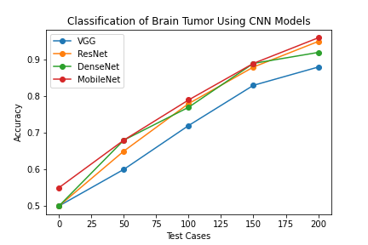

**Figure.6.3 Graph of Test Cases versus Accuracy of each CNN Model**

Various CNN classification models, including VGG, ResNet, DenseNet and MobileNet, are employed for brain tumor detection. The models are trained using 80% of the dataset, and the remaining 20% is reserved for testing. The classification results from each model are combined through ensemble techniques, and the final decision is based on majority voting. This approach incorporates multiple accuracy measures to enhance the overall precision in identifying brain tumor.

Accuracy=

**Table.6.4. Accuracy of Classification Models Trained**

|  |  |
| --- | --- |
| Classification Algorithms | Accuracy |
| VGG(Visual Geometry Group) | 0.880000 |
| ResNet(Residual Neural Network)  DenseNet(Densely Connected Network)  MobileNet(Mobile and Embedded Vision Application) | 0.910000  0.900000  0.920000 |

Specifically, the Convolutional Neural Network (CNN) demonstrated notable success in accurately identifying brain tumor. This robust performance establishes CNN as a highly suitable algorithm for this critical task. The substantial dataset size and the resulting high accuracy lend credibility to the reliability of CNN in practical applications, emphasizing its potential as a valuable tool in the field of medical image analysis. In research, the brain tumordetection using four distinct algorithms: Visual Geometry Group (VGG), Residual Neural Network (ResNet), Densely Connected Convolutional Network (DenseNet) and Mobile and embedded vision application (MobileNet).

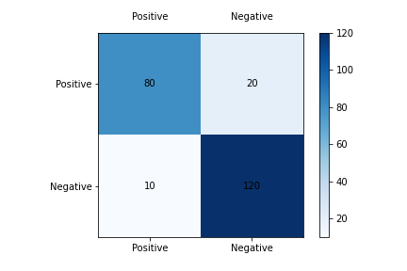

**Fig.6.5 Confusion Matrix**

### 6.4 Summary

The chapter concludes with a discussion of the technologies employed in implementing this project, along with the presentation of accuracy metrics, graphs, and a confusion matrix.

## CHAPTER SEVEN

## TESTING AND PERFORMANCE

### General Introduction

### 

In this section, we will discuss the output of this project. Below screenshots displays the results of different pages involved in this project.

* 1. **Results**

**7.2.1 Select MRI Image option**

The initial step involves providing the system with a brain MRI image, which could be either a representation of a normal brain or one depicting the presence of a brain tumor. This input image undergoes a processing phase where the system analyzes and extracts relevant features. The processing stage is key as it lays the foundation for following steps in the algorithm. This initial processing step serves as the threshold, enabling the system to discern key patterns and characteristics within the brain image, setting the stage for further examination and classification.

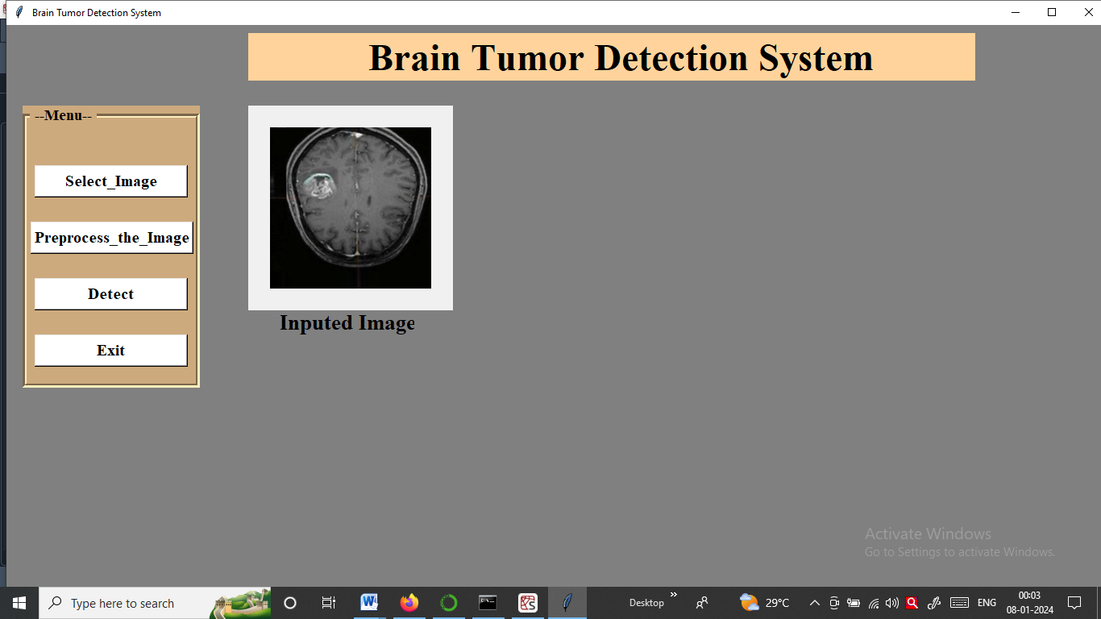

**Screenshot 7.1: Selected Input Image**

### Preprocessing the Input MRI Image and extract region of interest

In the processing phase, the brain image undergoes an important step known as grey feature extraction. This method systematically processes the entire dataset, focusing on isolating and removing the background portion of the brain. The goal is to generate a specific section of the brain that holds diverse features for analysis. By sharpening this particular region, the system enhances its ability to identify subtle abnormalities, such as the presence of a brain tumor. This targeted approach facilitates a more efficient and accurate determination of whether a brain tumor is present in the examined image or if the brain is in a normal state. The implementation of grey feature extraction thus simplifies the identification process, contributing to a more precise assessment of brain health.

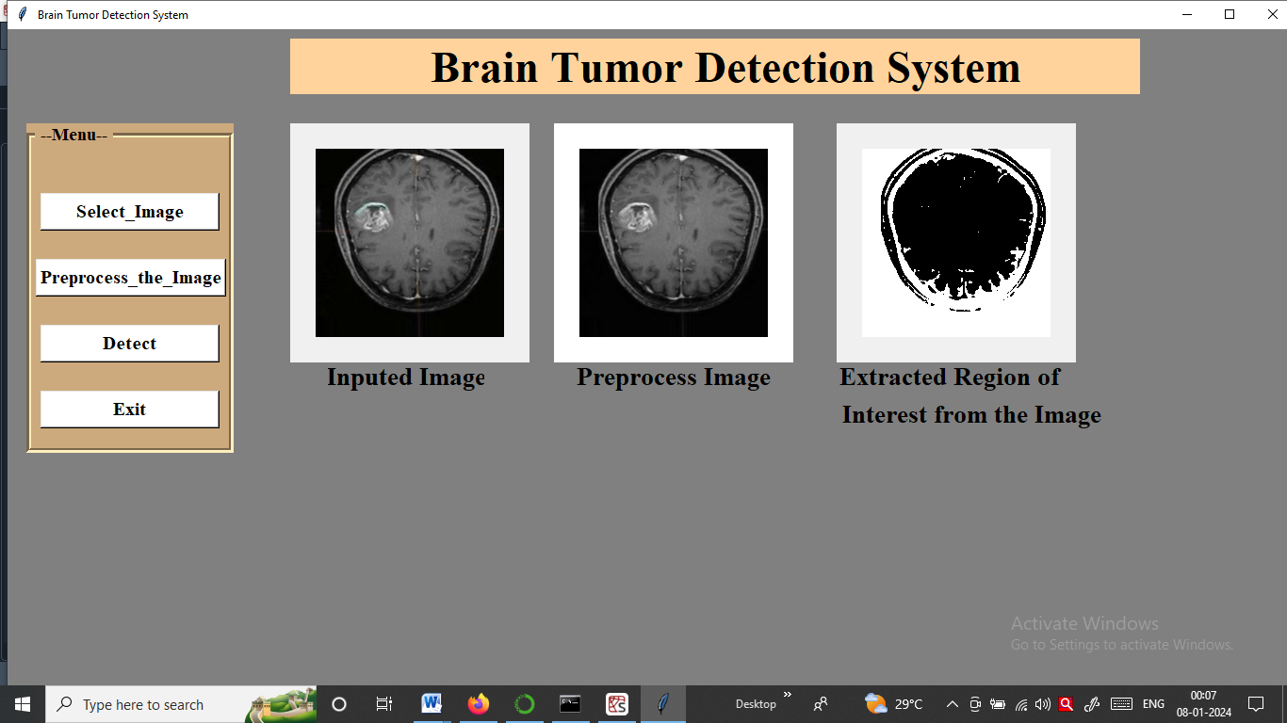

**Screenshot 7.2: Preprocessing the Input MRI Image and extract region of interest**

### Detect the Type of Abnormal Brain Growth

### Normal Brain

### Utilizing Convolutional Neural Network (CNN) prediction, the testing phase is necessary to determine whether a given brain image corresponds to a normal state. Following the processing steps, the CNN model, trained to recognize patterns and features indicative of normal brain structures, is applied to the tested image. Through this predictive analysis, the system can effectively discern whether the features extracted align with those typical of a healthy brain. This final step in the process serves as a determinative assessment, providing a clear identification of whether the examined brain image is indicative of a normal state or if deviations warrant further attention. The use of CNN prediction improves the accuracy and reliability of the system in classifying brain images and contributes to the overall effectiveness of the diagnostic approach.

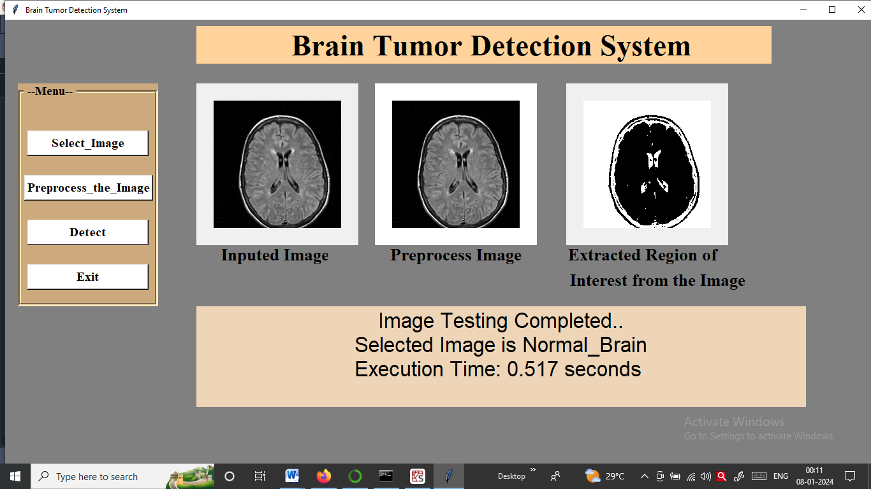

### Screenshot 7.3: Normal Brain Result

### Glioma Brain Tumor

In result of glioma brain tumor detected. High-grade gliomas represent a form of malignant, or cancerous, brain tumor characterized by their rapid growth and smooth spread within the central nervous system. Regrettably, the challenging nature of these brain tumor lies in their aggressive behavior and tendency to disseminate quickly. Unfortunately, there is currently no known cure for high-grade gliomas. The aggressive nature of these brain tumor makes them particularly difficult to treat comprehensively. Medical interventions for high-grade gliomas particularly focus on managing symptoms, slowing down the progression of the disease, and improving the individual's quality of life. This emphasizes the critical need for ongoing research and advancements in medical science to develop more effective treatments. Above five algorithms table describes that glioma brain tumor frequently occurs at the time of calculating accuracy.

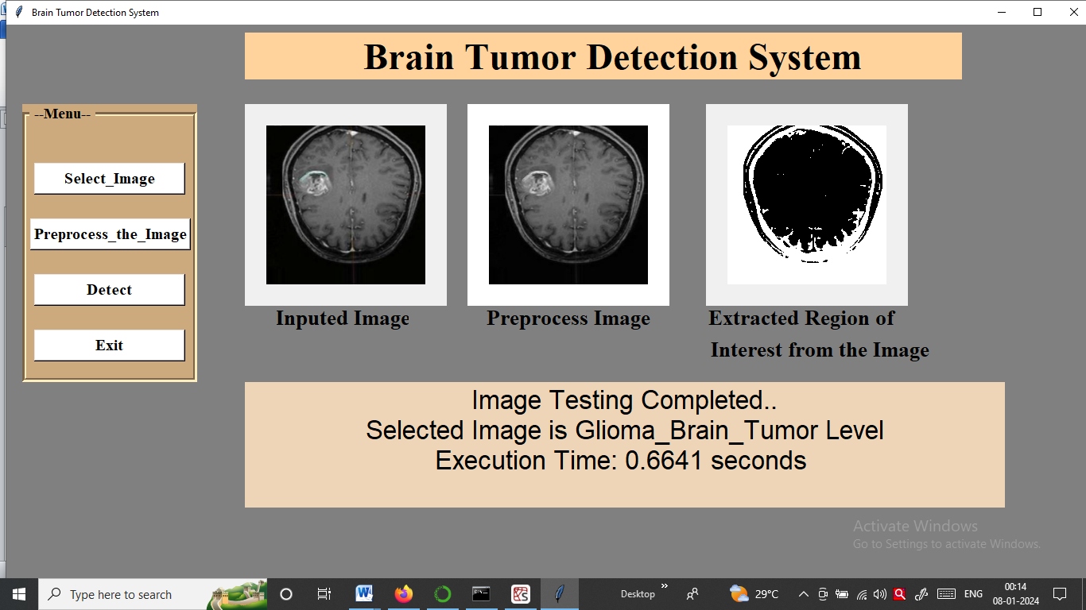

**Screenshot 7.4: Glioma Brain Tumor Result**

### Meningioma Brain Tumor

In cases where meningioma displays signs of growth or activate symptoms, surgical interruption may be recommended by healthcare providers. The primary goal of surgery is the complete removal of the meningioma. Fortunately, meningiomas are generally classified as benign brain tumor, meaning they are not cancerous, and in many cases, they are curable through surgical procedures. The surgical path aims to eliminate the brain tumor, addressing both the symptoms and the potential for further growth. This form of intervention is considered effective and offers a positive prognosis for individuals diagnosed with meningiomas. It emphasizes the importance of timely medical attention and the potential for successful treatment when meningioma’s exhibit signs of progression. Above five algorithms table describes that meningioma brain brain tumor frequently occurs as much compared to glioma brain tumor at the time of calculating accuracy.

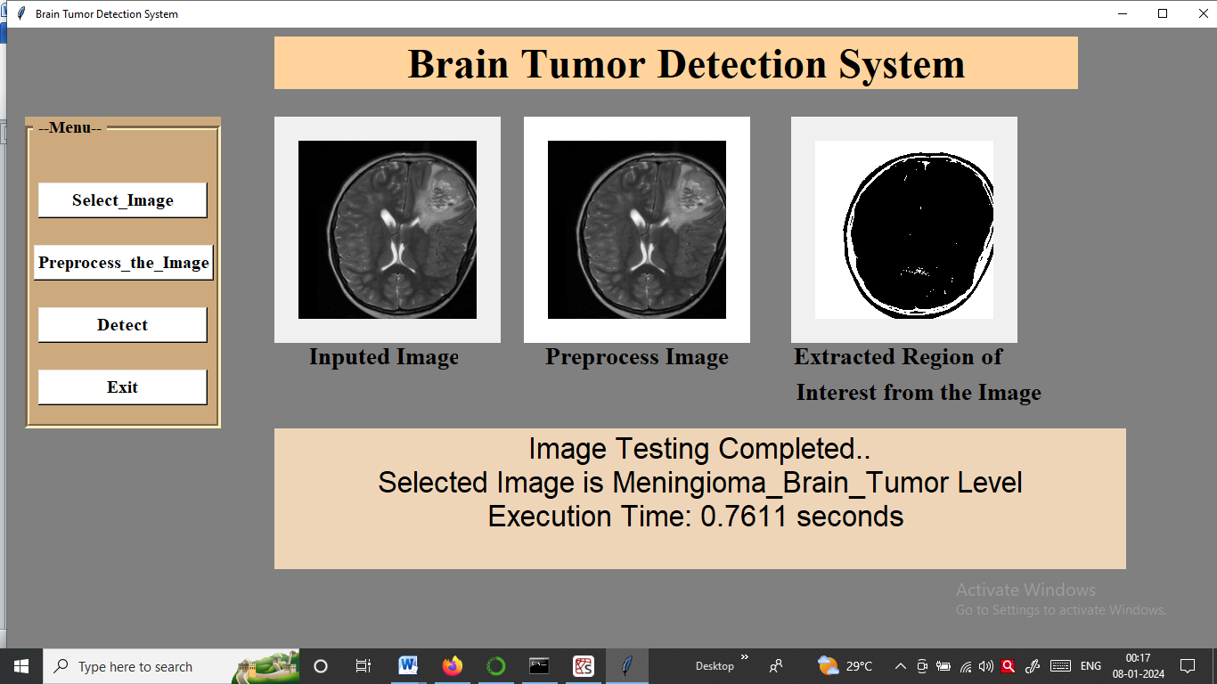

**Screenshot 7.5: Meningioma Brain Tumor Result**

**Pituitary Brain Tumor**

Identifying a pituitary brain tumor at an early stage is important, as it offers the opportunity for successful treatment and control. Early detection significantly improves the chances of a cure or effective management. It's important to note that pituitary brain tumor are generally considered curable, especially when diagnosed in their initial phases. Timely mediation enables healthcare professionals to implement appropriate treatment strategies, which may include surgical removal or other targeted therapies. The emphasis on early detection underscores the positive outcomes and the potential for a favourable prognosis in addressing pituitary brain tumor. These highlight the importance of regular medical check-ups and prompt medical attention when symptoms arise, contributing to the overall effectiveness of managing and treating pituitary brain tumor. Above five algorithms describes that pituitary brain tumor frequently occurs as much compared to glioma brain tumor and meningioma brain tumor at the time of calculating accuracy.

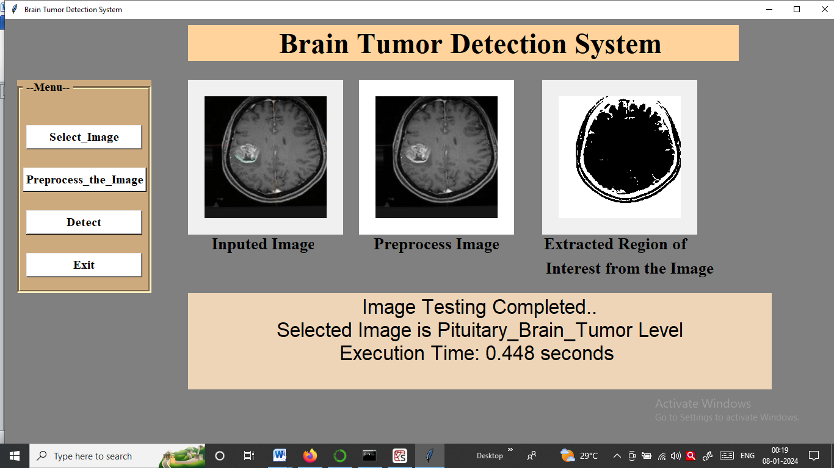

**Screenshot 7.6: Pituitary Brain Tumor Result**

**7.3 Summary**

Here we performed testing of this project and captured above results which shows the different types of brain tumor. For each module, there is separate section to perform its designated functionality.

## CHAPTER EIGHT

## CONCLUSION AND FUTURE SCOPE

### Conclusion

The developed MRI brain tumor detection system proves to be highly valuable for pathologists in effortlessly identifying and categorizing the presence of brain tumor without the need for manual intervention. The system employs an ensemble approach, utilizing multiple instances of the VGG, ResNet, DenseNet and MobileNet model with varied initializations. This ensemble strategy enhances accuracy by reducing over fitting and promoting robustness against noise and outliers in the training data. By combining predictions from diverse models, the system demonstrates improved performance compared to a single model, ultimately increasing the precision of MRI brain tumor detection. The success of this ensemble approach highlights its effectiveness in providing reliable and accurate results for the crucial task of brain tumor detection in MRI scans.

* 1. **Future Scope of the Work**

To further enhance the system, future considerations could involve expanding the dataset and working with other CNN models such as LeNet, AlexNet, GoogLeNet, and EfficientNet.

## REFERENCES

[1] Pendela Kanchanamala, Revathi K.G, M. Belsam Jeba Ananth Optimization-enabled hybrid deep learning for brain tumor detection and classification from MRI 2023. https://doi.org/10.1016/j.measen.2022.100440

[2] Suraj Patil, Dnyaneshwar Kirange Ensemle of deep learning models for brain tumor detection 2023<https://doi.org/10.1016/j.procs.2023.01.222>.

[3] Abhranta Panigrahi, Abdulhamit Subasi Magnetic resonance imagining-based automated brain tumor detection using deep learning techniques 2023. <https://doi.org/10.1016/B978-0-443-18450-5.00012-8>

[4] Ramdas Vankdothu, Mohd Abdul Hameed Brain tumor segmentation of MR images using SVM and fuzzy classifier in machine learning 2022. <https://doi.org/10.1016/j.measen.2022.100440>

[5] Yi-Xin Huang , Chi-Yuan Wang ,Yung-Hui Huang , Kuo-Ying Liu , Tai-Been Chen composite CNN strategies for improved classification of brain tumor of MRI with multiple sequence 2022<https://doi.org/10.1016/j.proce.2022.02.222>.

[6] Hossain, Roliana Binti Ibrahim, Haslina Binti Hashim Automated Brain Tumor Detection Using Machine Learning 2023. <https://doi.org/10.1016/j.wneu.2023.03.115>.

[7] Ashwini S Shinde a, BM Mahendra b,Santosh Nejakar c, Santosh M Herur d, Nagaraj Bhat b Performance analysis of machine learning algorithm of detection and classification of brain tumor using computer vision 2022. <https://doi.org/10.1016/j.advengsoft.2022.103221>

[8] Omer Turk, Davut ozhan, Emrullah acar, Tahir cetlin akinci, and Musa yilmaz deep learning architectures and utilizing class activation map indicators derived from magnetic resonance images 2022. <https://doi.org/10.1016/j.zemedi.2022.11.010>

[9] Parin Razzaghi, Karim Abbasi, Mahmoud Shirazi, Shima Rashidi Multimodal brain tumor detection using multimodal deep transfer learning 2022. <https://doi.org/10.1016/j.asoc.2022.109631>

[10] Arkapravo Chattopadhyay, Mausumi Maitra MRI-based brain tumor image detection using CNN based deep learning method 2022. <https://doi.org/10.1016/j.neuri.2022.100060>

[11] K.S. Ananda Kumar, A.Y. Prasad J. Metan A hybrid deep CNN-Cov-19-Res-Net Transfer learning architype for an enhanced Brain tumor Detection and Classification scheme in medical image processing 2022. <https://doi.org/10.1016/j.bspc.2022.103631>

[12] Dillip Ranjan Nayak, Neelamadhab Padhy, Pradeep Kumar Mallick, and Ashish Singh a deep auto encoder approach for detection of brain tumor images 2022. <https://doi.org/10.1016/j.compeleceng.2022.108238>

[13] B.P.Santosh Kumar , ShafiullaBasha Shaik , Harikrishna Mulam High-performance compression- based brain tumor detection using lightweight optimal deep neural network 2022. <https://doi.org/10.1016/j.advengsoft.2022.103248>

[14] Md. Saikat Islam Khan , Anichur Rahman , Tanoy Debnath , Md. Razaul Karim , Mostofa Kamal Nasir, Shahab S. Ban, Iman Dehzangi Accurate brain tumor detection using deep convolutional neural network 2022. <https://doi.org/10.1016%2Fj.csbj.2022.08.039>

[15] Bhuvanjeet Singh Gandhi, Shaik Ateeq Ur Rahman, Akash Butar, Akila Victor Brain tumor segmentation and detection in magnetic resonance imaging (MRI) using convolutional neural network 2022. <https://doi.org/10.1016/B978-0-323-91171-9.00002-8>

[16] Marius Popescu, Antoanela Naaji Detection of small tumors of the brain using medical imaging 2021. <https://doi.org/10.1016/B978-0-12-822271-3.00013-X>

[17] V. Pooja, M. Karthik Kumar, K. Kamalesh Comparative analysis of segmentation techniques on MRI brain tumor images 2021. <https://doi.org/10.1016/j.matpr.2021.03.723>

[18] Xinheng Wu , Lei Bi , Michael Fulham , David Dagan Feng , Luping Zhou , Jinman Kim Unsupervised brain tumor segmentation using a symmetric-driven adversarial network 2021. <https://doi.org/10.1016/j.neucom.2021.05.073>

[19] Zeynab Barzegar, Mansour Jamzad Weighted label fusion learning framework for glioma tumor segmentation in brain MRI 2021. <https://doi.org/10.1016/j.bspc.2021.102617>

[20]Shao-Lun Lu, Heng-Chun Liao, Feng-Ming Hsu, ChunChih Liao, and Feipei Lai, Furen Xiao The intracranial tumor segmentation challenge: Contour tumors on brain MRI for radiosurgery 2021. <https://doi.org/10.1016/j.neuroimage.2021.118585>

[21]Saroj Kumar Chandra, Manish Kumar Bajpai Fractional Crank-Nicolson finite difference method for benign brain tumor detection and segmentation2020. <https://doi.org/10.1016%2Fj.csbj.2021.08.039>

[22]Mansi Lather, Parvinder Singh Dr. Investigating Brain Tumor Segmentation and Detection Techniques 2020. <https://doi.org/10.1016/j.procs.2020.03.189>

[23]Muwei Jian, Xianxin Zhang, Lifu Ma, Hui Yu Tumor Detection in MRI Brain Images Based on Saliency Computational Modeling 2020. <https://doi.org/10.1016/j.ifacol.2021.04.123>

[24]Abdelaziz Essadike, Elhoussaine Ouabida, Abdenbi Bouzid Optical scanning holography for tumor extraction from brain magnetic resonance images2020. <https://doi.org/10.1016/j.ejmp.2020.03.014>

[25] Javaria Amin , Muhammad Sharif , Mudassar Raza , Tanzila Saba , Muhammad Almas Anjum Brain tumor detection using statistical and machine learning method 2019. <https://doi.org/10.1016/j.cmpb.2019.05.015>

[26]Fatih Özyurt , Eser Sert , Engin Avci , Esin Dogantekin Brain tumor detection based on Convolutional Neural Network with neutrosophic expert maximum fuzzy sure entropy 2019. <https://doi.org/10.1016/j.measurement.2019.07.058>

[27]T. Kalaiselvi, P. Kumara Shankar , P. Sriramakrishnan , S. Karthigaiselvi Brain Tumor Detection from Multimodal MRI Brain Images using Pseudo Coloring Processes 2019. <https://doi.org/10.1016/j.procs.2020.01.094>

[28]P.K. Bhagat, Prakash Choudhary, Kh. Manglem SinghA comparative study for brain tumor detection in MRI images using texture features 2019. <https://doi.org/10.1016/B978-0-12-819361-7.00013-0>

[29] Saroj Kumar Chandra, Manish Kumar Bajpai Mesh free alternate directional implicit method based three dimensional super-diffusive model for benign brain tumor segmentation 2019. <https://doi.org/10.1016/j.camwa.2019.02.009>

[30] Padmanaban Sriramakrishnan, Thiruvenkadam Kalaiselvi, Rangasami Rajeswaran Modified local ternary patterns technique for brain tumor segmentation and volume estimation from MRI multi-sequence scans with GPU CUDA machine 2019. <https://doi.org/10.1016/j.bbe.2019.02.002>



J. Integr. Sci. Technol. 2024, 12(4), 785

Journal of Integrated

SCIENCE & TECHNOLOGY

Frequent CNN based ensembling for MRI classification for Abnormal Brain Growth detection

# V.V. Bag,* M.B. Patil, Sanika Nagnath Kendre

## Department of Computer Science & Engineering, N. K. Orchid College of Engineering and Technology Solapur, Maharashtra, India.

Article

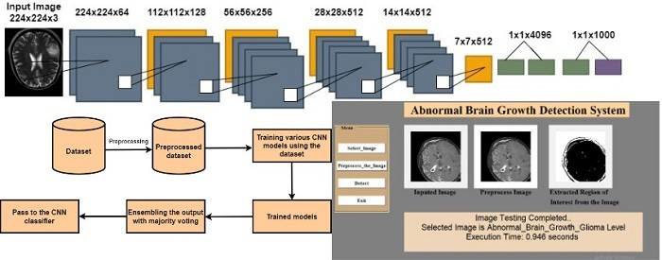Received on: 10-Dec-2023, Accepted 25-Dec-2023 and published on: 27-Dec-2023

**ABSTRACT**

Digital image processing is a key player in the analysis of medical images, particularly in understanding the intricacies of abnormal brain growth

development. Notably, the application of CNN algorithms to MRI images accelerates

abnormal brain growth detection with enhanced accuracy; facilitating prompt decision-making by radiologists. This research focuses on finding abnormal brain growth using advanced CNN computer techniques. The study is split into three main steps. In the first step, brain MRI images are pre-processed by applying selected pre-processing techniques. In the second step, machine learning feature extraction methods are applied to pick out important features from these images. Finally, CNN models such as VGG, ResNet, DenseNet, and MobileNet are applied to classify the MRI images at a detailed level. The ensemble is done to improve the accuracy of the classification of MRI images. The results from study indicate easy automated abnormal brain growth detection that save radiologists' time and improve the efficiency of early diagnosis.

*Keywords: Abnormal Brain Growth, Digital Pathology, CNN, VGG19, ResNet, DenseNet, MobileNet*

**INTRODUCTION**

The human body comprises various cell types, each with a specific function, growing and dividing in an orderly manner to maintain overall health. However, when certain cells lose control over their growth, they form a mass known as a abnormal brain growth. abnormal brain growth result from abnormal cell development, and they can be benign or malignant. Malignant tumors lead to cancer, while benign tumors are non-cancerous.1 Abnormal brain growth originate from uncontrolled cell

*Corresponding Author: Dr. V.V. Bag, Professor, CSE Dept., N. K. Orchid College of Engineering and Technology, Solapur, Maharashtra, India. Email: [vipulbag@gmail.com](mailto:vipulbag@gmail.com)

proliferation, affecting brain cells, membranes, glands, or nerves. They may weaken brain cells and exert pressure inside the skull, posing a challenge in medical diagnosis. Medical imaging data from devices like X-rays and CT scans are crucial for accurate diagnosis.2 Abnormal brain growth diagnosis is challenging due to the diverse characteristics of abnormal cells in brain, such as shape, size, and location. Early detection is difficult, but once identified, appropriate treatments like chemotherapy, radiotherapy, and surgery can be initiated. Medical imaging technology, including CT scanners, Ultrasound, and Magnetic Resonance Imaging, revolutionized diagnosis and enabled minimally invasive surgeries. Digital image processing techniques enhance data interpretation for physicians.3 Abnormal brain growth are categorized as primary or secondary, with primary abnormal brain growth originating in the brain. They are further classified as benign or malignant, each requiring specific treatment approaches. Malignant abnormal brain growth are more serious, potentially spreading to nearby healthy tissue. Convolutional Neural Network (CNN) frameworks aid in segmentation-free feature extraction, contributing to abnormal brain growth detection. Detecting abnormal brain growth is challenging due to variations in location, type, size, and shape. Early identification is crucial for treatment decisions and improved chances of survival. Machine learning techniques, specifically CNN-based, classify brain images as normal or abnormal, facilitating tumor extraction. The CNN model incorporates convolutional, max-pooling, flatten and fully connected layers. Current research focuses on the detection and classification of abnormal brain growth using advanced image processing and computer vision applications. Machine learning has proven effective feature extraction in biomedical fields, particularly in abnormal brain growth preprocessing through image analysis and detection through CNN models. This research aims to critically analyze existing findings to enhance the understanding of abnormal brain growth detection and classification using CNN models techniques are applied to brain MRI images.

Magnetic resonance imaging is a pivotal tool in abnormal brain growth detection and utilizes techniques like T1-weighted, T2- weighted, and contrast-enhanced imaging. This approach involves a three-stage process. Initially, examine the diversity of coarse regions in the MRI image. Extract shape and texture features from tiled regions, reduce the dimensionality of these features, and cluster them to create representative groups. In the second stage, it conducts a detailed analysis of a single representative tile from each group. Using CNN classifier, it generates a diagnostic decision value for each tile. A weighted voting scheme combines these decision values to provide a diagnosis for the entire image. This method aims to make the analysis more efficient and accurate. Strategically analyze coarse regions, extracting essential features such as shape and texture from tiled sections. In essence, approach offers a nuanced and efficient solution to the complexities posed by large pathology images, ensuring that the computerized analysis is not only accurate but also focused on the relevant information critical for diagnosis and research advancements.

**LITERATURE SURVEY**

In the research paper by Ramdas Vankdothu, et.al.4 explained these scans are commonly employed in diagnosing various conditions like head traumas, malignancies, and skull injury. Primary focus was on enhancing the efficiency and simplifying the complexity associated with the segmentation process of CT-based images. By investigating and refining the segmentation techniques specific to CT scans, aim to contribute to a more streamlined and effective approach to identifying and delineating abnormal brain growth in these diagnostic images. This research holds promise for improving the overall diagnostic process for conditions affecting the brain, offering potential benefits in terms of accuracy and speed. Yi-Xin Huang, et.al.5 suggested CNN-based deep learning model for sorting many forms of abnormal brain growth, where the design has an ordering accuracy for the group of abnormal brain growth types. Hossain6 contributed to the collective understanding of automated abnormal brain growth detection, offering valuable insights to researchers, practitioners, and stakeholders in the medical and machine learning communities. This type of study is crucial for staying abreast of the latest developments in the field, guiding future research directions, and ultimately advancing the capabilities of automated abnormal brain growth detection systems. Ashwini S Shinde, et.al.7 evaluated several cutting-edge Machine Learning techniques designed for tumor classification, distinguishing between benign and malignant cases. The investigated methods encompass a diverse array of approaches, including Logistic Regression, Multilayer Perceptron, Decision Trees, Naive Bayes classifier, and Support Vector Machines. The aim is to comprehensively analyse the effectiveness and performance of each technique in the critical task of abnormal brain growth classification. By delving into these state-of-the-art methodologies, seek to discern their respective strengths and limitations, providing valuable insights into their applicability and potential contributions to enhancing the accuracy and reliability of tumor diagnosis. Omer Turk et.al.8 developed an automated system for detecting abnormal brain growth using advanced deep learning models, namely ResNet50, InceptionV3, and Mobile Net focusing on analyzing brain images, a crucial diagnostic tool. Additionally, we're incorporating Class Activation Maps (CAMs) indicators to enhance the interpretability of the models. By doing this, aim to create a more accurate and reliable method for identifying abnormal brain growth through the combination of these powerful deep- learning architectures and meaningful visualizations provided by CAMs. This approach could potentially improve the efficiency and precision of abnormal brain growth diagnosis using MRI scans.

Parvin Razzaghi, et.al.9 described the challenge of brain image segmentation, the concept of knowledge transfer, both between and within different modalities. A key aspect of this transfer is domain adaptation, which plays a crucial role in overcoming the issue of disparate distributions between the sets used for training and testing. Arkapravo Chattopadhyay, et.al.10 improved the accuracy of detecting and categorizing abnormal brain growth in MRI images by combining the strengths of both advanced neural networks and established classification techniques. This approach could lead to more precise and reliable results in identifying and understanding brain abnormalities from medical images. K.S. Ananda Kumar et al11 informed in simple terms, using a sophisticated neural network that has been pre-trained on a large dataset (inspired by nature) to quickly and accurately identify and categorize brain images. This approach combines the strengths of deep learning and transfer learning, aiming to improve the efficiency and accuracy of detecting various features in brain images for better classification.

Detecting abnormal brain growth poses challenges due to the diverse nature of tumor tissues among different patients, often resembling normal tissues, making the task complex. The primary objective of current study is to accurately classify the presence of a abnormal brain growth or a healthy brain, enabling early-stage detection.12 This methodology enhances the speed and precision of abnormal brain growth detection, providing automation in image processing and analysis, thereby improving the identification of brain structures in the realm of medical science. The focus extends to abnormal brain growth Segmentation, a critical medical image analysis task involving the separation of abnormal brain growth from normal brain tissue in imaging scans.13 Leveraging convolutional neural networks (CNN) proves advantageous, as they autonomously learn intricate features from multi-modal brain images, enhancing accuracy. This approach not only automates image processing but also contributes to the refined identification of both healthy and abnormal brain growth tissues. Recognizing the pivotal role of early-stage abnormal brain growth detection in increasing patient recovery chances after treatment, the study emphasizes the importance of image processing. The fundamental objective is to convert images into a digital format, enabling specific operations for obtaining models or extracting pertinent information from the images.14 The main goal is to significantly reduce the fatality rate associated with abnormal brain growth, underscoring the importance of early identification. The study aims to streamline the detection and classification of abnormal brain growth, particularly through the development of a segmentation and detection method utilizing MRI sequence images. This method serves as a valuable tool for identifying abnormal brain growth areas, contributing to the broader effort to improve outcomes in abnormal brain growth diagnosis and treatment.15

**METHODOLOGY**

According to the literature review, automated detection of abnormal brain growth is imperative, particularly when human lives are at stake, demanding high accuracy. The automated process involves the extraction of features and classification CNN algorithms.16 This paper introduces a system designed for the automatic detection of abnormal brain growth in MRI images. The application of various imaging techniques serves the ultimate purpose of extracting crucial information from the given MRI images. While the classification of abnormal brain growth is a vital yet time-intensive task performed by medical experts, the digital image processing community has made significant strides, developing numerous machine learning algorithms and CNN models.17 Extensive research has explored abnormal brain growth detection using image processing and soft computing techniques, each with its distinct advantages. The paper delves into the methods and algorithms employed in the proposed approach for the classification of brain MRI images. In Fig.1 it is shown the how data is pre-processed for training the various CNN models to make a trained classification model for abnormal brain growth detection. It shows rough idea about structure of the MRI abnormal brain growth detection and classification.18

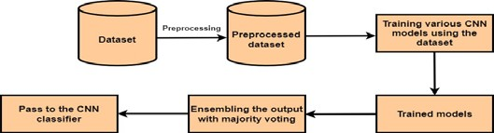

**Figure 1.** General system architecture

In Figure 2 detailed system architecture of abnormal brain growth detection and classification is shown. In first step MRI image to, train the classification algorithm using the MRI brain dataset. The accuracy of the learned model is calculated and it is evaluated. The various CNN models such as VGG, ResNet, DenseNet and MobileNet to make the best classification model for the detection of abnormal brain growth and gives brain images of patients as input to the classification model at the last ensemble the classification output for majority voting to detect the abnormal brain growth.19

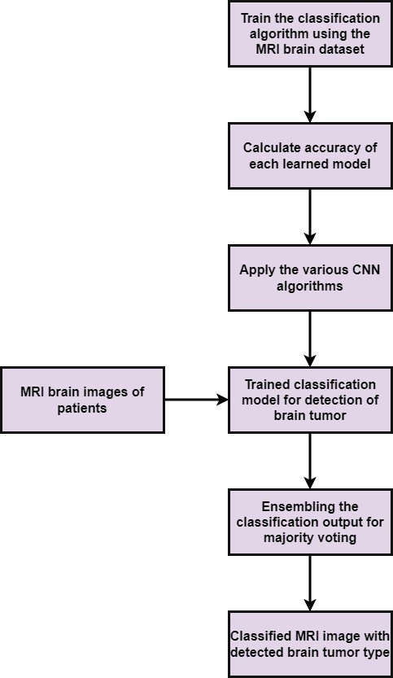

**Figure 2.** Detailed System Architecture

C:\Users\DELL\Downloads\cnn p.drawio.png **Figure 3.** MRI Image Data processing

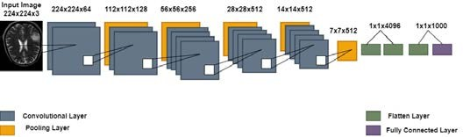 **Figure 4.** CNN Layer Processing

The dataset includes 1320 images of human brain MRI. These images are classified into three types: glioma, meningioma, and pituitary. 330 images of glioma abnormal brain growth, raises to cancer that disturbs the brain, cranial nerves, or other portions of the nervous system. 330 images of pituitary abnormal brain growth, Pituitary abnormal brain growth.20

It initiate in the pituitary gland, which is found inside the skull but is not part of the brain.330 images of meningioma brain tumors, On the other hand, meningioma tumors develop from the meninges, the membrane that shields the brain and spinal cord. They are the most common primary brain tumors in adults. And the other 330 are normal brains.21

To enhance accuracy, preprocessing steps are undertaken to eliminate artifacts present in these images. In Fig.3 the processing time is optimized by excluding unnecessary information from the image background, such as the skull, background and scalp, leaving only the region of interest. The Brain Surface Extractor employed to effectively remove the brain and skull. Preprocessing proves essential as it not only eliminates unwanted elements but also improves the overall image data, enhancing crucial features necessary for subsequent processing steps.22

A VGG19 (Visual Geometry Group 19) Convolutional Neural Network (CNN) architecture is a type of deep neural network it consists of 19 layers that employs various convolutional layers to sift through inputs and extract useful information. Convolutional filters are applied to the input data in these layers, calculating the output of neurons linked to specific regions in the input. Fig.4 the CNN model consists of four key layers: a convolutional layer, a pooling layer, flatten layer and a fully connected layer. The convolutional layer involves essential parameters like stride, padding, and filter size. Multiple filters are utilized in each layer to extract detailed features. The filters move across the images based on a specified stride, where a stride size of one or two is typically employed; exceeding this value can negatively impact CNN performance.23 Each convolutional layer is designed to carry out a specific task in the overall process. The number of filters increases deeper into the network, providing a hierarchical feature representation. Pooling layer helps reduce the spatial dimensions of the feature maps, leading to a more compact representation and capturing the most important features, it preserves important information extracted by the convolutional layers. Flatten layer connecting the spatial information captured by to the densely connected layers that make classification decisions. Fully connected layer uses softmax activation to produce probability scores for different classes. These scores in the presence of each class in the input image. After completing all layers it classifies whether the abnormal brain growth has occur or not.24

**RESULTS AND DISCUSSION**

The study conducted focused on analysing brain images through a process that involved extracting texture-based features. These features serve as distinctive characteristics derived from the patterns and textures within the images. The utilization of a specialized model was inherent to the following classification task.25 This model, trained on the abstract texture features, played a pivotal role in categorizing and distinguishing different aspects or conditions within the brain images. By grasping advanced techniques for feature extraction and employing a tailored classification model, the research aimed to enhance understanding of the intricate details present in the brain images, contributing to more accurate and fine classifications for various neurological conditions or characteristics.26 This approach emphasizes the importance of combining advanced imaging analysis with advanced computational models to glean meaningful insights from complex datasets.27

**Algorithm: CNN Classification for Abnormal Brain Growth Detection**

Input: Brain Image

Output: Classified abnormal brain growth Label Use the MRI image dataset for model training

Train the model using convolutional neural network (VGG, ResNet, DenseNet, and MobileNet)

Using cross validation score calculate the accuracy of various models

Input the test image 100X100 pixels.

Use trained model to predict the class label of abnormal brain growth

Make a list of predicted class labels for various trained models

By ensembling find the final class label of the abnormal brain growth by majority voting

The F1 score is calculated using precision and recall. It combines precision and recall into a single value; it is used for uneven class distribution. Precision is the ratio of true positives. Precision focuses on the accuracy of positive predictions. It works on True Positive (TP), false Positive (FP) and False Negative (FN).28

Table1. Classification Report of CNN Algorithm

|  |  |  |  |  |
| --- | --- | --- | --- | --- |
| **Class** | **Precision** | **Recall** | **F1_score** | **Support** |
| Normal Brain | 0.83 | 0.91 | 0.87 | 390 |
| Glioma abnormal brain growth | 0.88 | 0.83 | 0.87 | 460 |
| Meningioma abnormal brain growth | 0.91 | 0.86 | 0.90 | 460 |
| Pituitary abnormal brain growth | 0.93 | 0.88 | 0.92 | 370 |
| Accuracy | 0.90 | 560 | - | - |
| Macro avg | 0.87 | 0.91 | 0.88 | 560 |
| Weighted avg | 0.89 | 0.90 | 0.90 | 560 |

F1_score = ……………(1)

It combines two important performance measures: precision and recall. Precision represents the accuracy of positive predictions, while recall (or sensitivity) measures the ability of the model to capture all the relevant instances.

Precision = ……………………………(2)

Precision is the number of true positives divided by the sum of true positives and false positives. It is a measure of the accuracy of positive predictions.

Recall = ……………………………………….(3)

Recall is the number of true positives divided by the sum of true positives and false negatives. It is a measure of the model's ability to capture all the relevant instances.

**Table 2**. Classification Models with Cross Validation Score

|  |  |  |  |  |
| --- | --- | --- | --- | --- |
| **Model** | **CV score**  **K=1** | **CV score**  **K=2** | **CV score**  **K=3** | **CV score**  **K=4** |
| VGG | 0.95 | 0.92 | 0.91 | 0.95 |
| ResNet | 0.90 | 0.90 | 0.90 | 0.90 |
| DenseNet | 0.89 | 0.90 | 0.91 | 0.92 |
| MobileNet | 0.87 | 0.88 | 0.86 | 0.86 |

The initial step involves providing the system with a brain MRI image, which could be either a representation of a normal brain or one depicting the presence of a abnormal brain growth. This input image undergoes a processing phase where the system analyzes and extracts relevant features. The processing stage is key as it lays the foundation for following steps in the algorithm. This initial processing step serves as the threshold, enabling the system to discern key patterns and characteristics within the brain image, setting the stage for further examination and classification.29

In the processing phase, the brain image undergoes an important step known as grey feature extraction. This method systematically processes the entire dataset, focusing on isolating and removing the background portion of the brain. The goal is to generate a specific section of the brain that holds diverse features for analysis. By sharpening this particular region, the system enhances its ability to identify subtle abnormalities, such as the presence of a abnormal brain growth. This targeted approach facilitates a more efficient and accurate determination of whether a abnormal brain growth is present in the examined image or if the brain is in a normal state. The implementation of grey feature extraction thus simplifies the identification process, contributing to a more precise assessment of brain health.30

Utilizing Convolutional Neural Network (CNN) prediction, the testing phase is necessary to determine whether a given brain image corresponds to a normal state. Following the processing steps, the CNN model, trained to recognize patterns and features indicative of normal brain structures, is applied to the tested image. Through this predictive analysis, the system can effectively discern whether the features extracted align with those typical of a healthy brain. This final step in the process serves as a determinative assessment, providing a clear identification of whether the examined brain image is indicative of a normal state or if deviations warrant further attention. The use of CNN prediction improves the accuracy and reliability of the system in classifying brain images and contributes to the overall effectiveness of the diagnostic approach.31

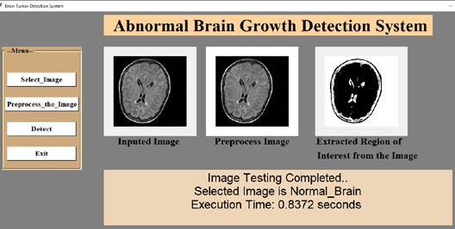

**Figure 5.** Classification of Abnormal Brain Growth as Normal

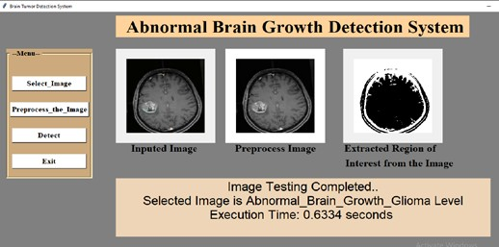

**Figure 6.** Classification of Abnormal Brain Growth as Glioma

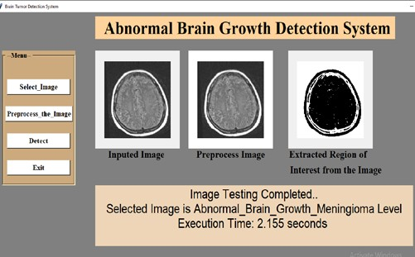

**Figure 7.** Classification of Abnormal Brain Growth as Meningioma

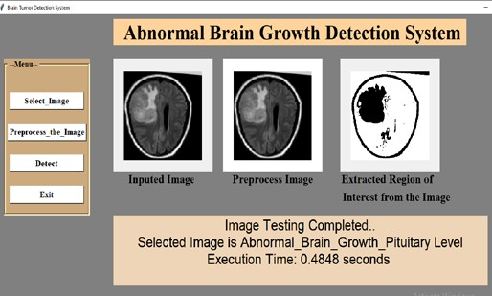**Figure 8.** Classification of Abnormal Brain Growth as Pituitary

In Figure 5 result of glioma abnormal brain growth detected. High-grade gliomas represent a form of malignant, or cancerous, abnormal brain growth characterized by their rapid growth and smooth spread within the central nervous system. Regrettably, the challenging nature of these abnormal brain growth lies in their aggressive behavior and tendency to disseminate quickly. Unfortunately, there is currently no known cure for high-grade gliomas. The aggressive nature of these abnormal brain growth makes them particularly difficult to treat comprehensively. Medical interventions for high-grade gliomas particularly focus on managing symptoms, slowing down the progression of the disease, and improving the individual's quality of life. This emphasizes the critical need for ongoing research and advancements in medical science to develop more effective treatments. Above five algorithms table describes that glioma abnormal brain growth frequently occurs at the time of calculating accuracy.32smooth spread within the central nervous system. Regrettably, the challenging nature of these abnormal brain growth lies in their aggressive behavior and tendency to disseminate quickly. Unfortunately, there is currently no known cure for high-grade gliomas. The aggressive nature of these abnormal brain growth makes them particularly difficult to treat comprehensively. Medical interventions for high-grade gliomas particularly focus on managing symptoms, slowing down the progression of the disease, and improving the individual's quality of life. This emphasizes the critical need for ongoing research and advancements in medical science to develop more effective treatments. Above five algorithms table describes that glioma abnormal brain growth frequently occurs at the time of calculating accuracy.32

In cases where meningioma displays signs of growth or activate symptoms, surgical interruption may be recommended by healthcare providers. The primary goal of surgery is the complete removal of the meningioma. Fortunately, meningiomas are generally classified as benign abnormal brain growth, meaning they are not cancerous, and in many cases, they are curable throughsurgical procedures. The surgical path aims to eliminate the abnormal brain growth, addressing both the symptoms and the potential for further growth. This form of intervention is considered effective and offers a positive prognosis for individuals diagnosed with meningiomas. It emphasizes the importance of timely medical attention and the potential for successful treatment when meningioma’s exhibit signs of progression. Above five algorithms table describes that meningioma brain abnormal brain growth frequently occurs as much compared to glioma abnormal brain growth at the time of calculating accuracy.

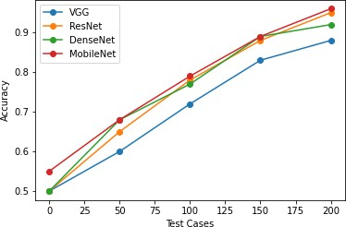**Figure 9.** Graph of Test Cases versus Accuracy of each CNN Model

Identifying a pituitary abnormal brain growth at an early stage is important, as it offers the opportunity for successful treatment and control. Early detection significantly improves the chances of a cure or effective management. It's important to note that pituitary abnormal brain growth are generally considered curable, especially when diagnosed in their initial phases. Timely mediation enables healthcare professionals to implement appropriate treatment strategies, which may include surgical

removal or other targeted therapies. The emphasis on early detection underscores the positive outcomes and the potential for a favourable prognosis in addressing pituitary abnormal brain growth. These highlight the importance of regular medical check-ups and prompt medical attention when symptoms arise, contributing to the overall effectiveness of managing and treating pituitary abnormal brain growth. Above five algorithms describes that pituitary abnormal brain growth frequently occurs as much compared to glioma abnormal brain growth and meningioma abnormal brain growth at the time of calculating accuracy.

Various CNN classification models, including VGG, ResNet, DenseNet and MobileNet, are employed for abnormal brain growth detection. The models are trained using 80% of the dataset, and the remaining 20% is reserved for testing. The classification results from each model are combined through ensemble techniques, and the final decision is based on majority voting. This approach incorporates multiple accuracy measures to enhance the overall precision in identifying abnormal brain growth.

Accuracy=

**Table 3**. Accuracy of Classification Models Trained

|  |  |
| --- | --- |
| **Classification Algorithms** | **Accuracy** |
| VGG(Visual Geometry Group) | 0.880000 |
| ResNet(Residual Neural Network) | 0.910000 |
| DenseNet(Densely Connected Convolutional  Network) | 0.900000 |
| MobileNet(Mobile and Embedded Vision Application) | 0.920000 |

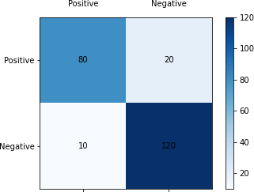 **Figure 10.** Confusion Matrix

Specifically, the Convolutional Neural Network (CNN) demonstrated notable success in accurately identifying abnormal brain growth. This robust performance establishes CNN as a highly suitable algorithm for this critical task. The substantial dataset size and the resulting high accuracy lend credibility to the reliability of CNN in practical applications, emphasizing its potential as a valuable tool in the field of medical image analysis. In research, the abnormal brain growth detection using four distinct algorithms: Visual Geometry Group (VGG), Residual Neural Network (ResNet), Densely Connected Convolutional Network (DenseNet) and Mobile and embedded vision application (MobileNet).

**CONCLUSION**

The developed MRI abnormal brain growth detection system proves to be highly valuable for pathologists in effortlessly identifying and categorizing the presence of abnormal brain growth without the need for manual intervention. The system employs an ensemble approach, utilizing multiple instances of the VGG, ResNet, DenseNet and MobileNet model with varied initializations. This ensemble strategy enhances accuracy by reducing over fitting and promoting robustness against noise and outliers in the training data. By combining predictions from diverse models, the system demonstrates improved performance compared to a single model, ultimately increasing the precision of MRI abnormal brain growth detection. The success of this ensemble approach highlights its effectiveness in providing reliable and accurate results for the crucial task of abnormal brain growth detection in MRI scans. To further enhance the system, future considerations could involve expanding the dataset and incorporating both intensity-based and texture-based features.

**CONFLICT OF INTEREST STATEMENT**

The authors declare that none of them has any conflict of interest.

**REFERENCES**

1. P. Kanchanamala, R. K.G., M.B.J. Ananth. Optimization-enabled hybrid deep learning for brain tumor detection and classification from MRI. *Biomed. Signal Process. Control* **2023**, 84, 104955.
2. S. Patil, D. Kirange. Ensemble of Deep Learning Models for Brain Tumor Detection. *Procedia Comput. Sci.* **2023**, 218, 2468–2479.
3. A. Panigrahi, A. Subasi. Magnetic resonance imagining-based automated brain tumor detection using deep learning techniques. In *Applications of Artificial Intelligence in Medical Imaging*; Elsevier, **2023**; pp 75–107.
4. R. Vankdothu, M.A. Hameed. Brain tumor segmentation of MR images using SVM and fuzzy classifier in machine learning. *Meas. Sensors* **2022**, 24, 100440.
5. Y.-X. Huang, C.-Y. Wang, Y.-H. Huang, K.-Y. Liu, T.-B. Chen. Composite CNN strategies for improved classification of brain tumors on mri with multiple sequences. *J. Med. Imaging Radiat. Sci.* **2023**, 54 (3), S6.
6. R. Hossain, R.B. Ibrahim, H.B. Hashim. Automated Brain Tumor Detection Using Machine Learning: A Bibliometric Review. *World Neurosurg.* **2023**, 175, 57–68.
7. A.S. Shinde, B. Mahendra, S. Nejakar, S.M. Herur, N. Bhat. Performance analysis of machine learning algorithm of detection and classification of brain tumor using computer vision. *Adv. Eng. Softw.* **2022**, 173, 103221.
8. O. Turk, D. Ozhan, E. Acar, T.C. Akinci, M. Yilmaz. Automatic detection of brain tumors with the aid of ensemble deep learning architectures and class activation map indicators by employing magnetic resonance images.

*Z. Med. Phys.* **2022**.

1. P. Razzaghi, K. Abbasi, M. Shirazi, S. Rashidi. Multimodal brain tumor detection using multimodal deep transfer learning. *Appl. Soft Comput.* **2022**, 129, 109631.
2. A. Chattopadhyay, M. Maitra. MRI-based brain tumour image detection using CNN based deep learning method. *Neurosci. Informatics* **2022**, 2 (4), 100060.
3. K.S. Ananda Kumar, A.Y. Prasad, J. Metan. A hybrid deep CNN-Cov-19- Res-Net Transfer learning architype for an enhanced Brain tumor Detection and Classification scheme in medical image processing. *Biomed. Signal Process. Control* **2022**, 76, 103631.
4. D.R. Nayak, N. Padhy, P.K. Mallick, A. Singh. A deep autoencoder approach for detection of brain tumor images. *Comput. Electr. Eng.* **2022**, 102, 108238.
5. B.P.S. Kumar, S.B. Shaik, H. Mulam. High-performance compression- based brain tumor detection using lightweight optimal deep neural network. *Adv. Eng. Softw.* **2022**, 173, 103248.
6. M.S.I. Khan, A. Rahman, T. Debnath, et al. Accurate brain tumor detection using deep convolutional neural network. *Comput. Struct. Biotechnol. J.* **2022**, 20, 4733–4745.
7. B.S. Gandhi, S.A.U. Rahman, A. Butar, A. Victor. Brain tumor segmentation and detection in magnetic resonance imaging (MRI) using convolutional neural network. In *Brain Tumor MRI Image Segmentation Using Deep Learning Techniques*; Elsevier, **2022**; pp 37–57.
8. B. Kalva, M.C. Mohan. Effective image retrieval based on an optimized algorithm utilizing a novel WOA-based convolutional neural network classifier. *J. Integr. Sci. Technol.* **2023**, 11 (3), 523.
9. M. Popescu, A. Naaji. Detection of small tumors of the brain using medical imaging. In *Handbook of Decision Support Systems for Neurological Disorders*; Elsevier, **2021**; pp 33–53.
10. V. Pooja, M.K. Kumar, K. Kamalesh. Comparative analysis of segmentation techniques on MRI brain tumor images. *Mater. Today Proc.* **2021**, 47, 109–114.
11. X. Wu, L. Bi, M. Fulham, et al. Unsupervised brain tumor segmentation using a symmetric-driven adversarial network. *Neurocomputing* **2021**, 455, 242–254.
12. Z. Barzegar, M. Jamzad. WLFS: Weighted label fusion learning framework for glioma tumor segmentation in brain MRI. *Biomed. Signal Process. Control* **2021**, 68, 102617.
13. S.-L. Lu, H.-C. Liao, F.-M. Hsu, et al. The intracranial tumor segmentation challenge: Contour tumors on brain MRI for radiosurgery. *Neuroimage* **2021**, 244, 118585.
14. Y. Ma, A. Yao, X. Chen, et al. Generation of truncated derivatives through in silico enzymatic digest of peptide GV30 target MRSA both in vitro and in vivo. *Comput. Struct. Biotechnol. J.* **2021**, 19, 4984–4996.
15. M. Lather, P. Singh. Investigating Brain Tumor Segmentation and Detection Techniques. *Procedia Comput. Sci.* **2020**, 167, 121–130.
16. M. Jian, X. Zhang, L. Ma, H. Yu. Tumor Detection in MRI Brain Images Based on Saliency Computational Modeling. *IFAC-PapersOnLine* **2020**, 53 (5), 43–46.
17. K. Yang, C. Geng, X. Li, B. Liu. Quantitative evaluation of transmission properties of breast tissue equivalent materials under Compton scatter imaging setup. *Phys. Medica* **2020**, 72, 32–38.
18. J. Amin, M. Sharif, M. Raza, T. Saba, M.A. Anjum. Brain tumor detection using statistical and machine learning method. *Comput. Methods Programs Biomed.* **2019**, 177, 69–79.
19. F. Özyurt, E. Sert, E. Avci, E. Dogantekin. Brain tumor detection based on Convolutional Neural Network with neutrosophic expert maximum fuzzy sure entropy. *Measurement* **2019**, 147, 106830.
20. T. Kalaiselvi, P. Kumarashankar, P. Sriramakrishnan, S. Karthigaiselvi. Brain Tumor Detection from Multimodal MRI Brain Images using Pseudo Coloring Processes. *Procedia Comput. Sci.* **2019**, 165, 173–181.
21. P.K. Bhagat, P. Choudhary, K.M. Singh. A comparative study for brain tumor detection in MRI images using texture features. In *Sensors for Health Monitoring*; Elsevier, **2019**; pp 259–287.
22. S.K. Chandra, M.K. Bajpai. Mesh free alternate directional implicit method based three dimensional super-diffusive model for benign brain tumor segmentation. *Comput. Math. with Appl.* **2019**, 77 (12), 3212–3223.
23. P. Sriramakrishnan, T. Kalaiselvi, R. Rajeswaran. Modified local ternary patterns technique for brain tumour segmentation and volume estimation from MRI multi-sequence scans with GPU CUDA machine. *Biocybern. Biomed. Eng.* **2019**, 39 (2), 470–487.
24. M.K. Abd-Ellah, A.I. Awad, A.A.M. Khalaf, H.F.A. Hamed. A review on brain tumor diagnosis from MRI images: Practical implications, key achievements, and lessons learned. *Magn. Reson. Imaging* **2019**, 61, 300– 318.